Toward universal broadband access
in Australia –
The National Broadband Network

July 2012

This case study has been prepared by Mr Colin Oliver, ITU Expert, within the framework of an ITU-NBTC-PTA workshop on Broadband Policy and Regulation held in August 2011. It updates an earlier case study prepared by Mr Oliver in 2009 and has been developed with the support of the National Broadcasting and Telecommunications Commission, Thailand. This case study includes information until 2011.

© ITU 2012
All rights reserved. No part of this publication may be reproduced, by any means whatsoever, without the prior written permission of ITU.

Table of contents
Page
1. Introduction 1
2. Broadband Requests for Proposals 10
3. National Broadband Network 13
4. Regulatory reforms and the universal service obligation 26
5. Broadband prospects, consequences and opportunities 37
6. Concluding remarks 43
Appendix 1: Timeline of key developments 45
Appendix 2: Reports and References 49
Appendix 3: List of acronyms and abbreviations 51

1. Introduction
In April 2009, the Australian Government announced that it would establish a company that would invest up to AUD 43 billion Australian dollars over the next eight years to build and operate a wholesale-only, open access National Broadband Network.
The National Broadband Network is to
• connect 93 per cent of all Australian homes, schools and workplaces with broadband services with speeds up to 100 megabits per second in towns with around 1000 people or more, and
• connect all other premises in Australia with next generation wireless (4%) and satellite technologies (3%) that will deliver broadband speeds of 12 megabits per second.
The National Broadband Network will remain a wholesale-only, open-access network and the government has announced its intention to sell down its interest in the company within 5 years after the network is built and fully operational.
An earlier case study completed in 2009 outlined the development of Australian policy toward the universal obligation and the development of rural and regional services in the period prior to and including the announcement of the National Broadband Network. When the 2009 case study was prepared, the government's broad intentions were clear, but much remained to be done. Since then, a number of developments called for an update of the case study:
• An Implementation Study clarified a range of measures needed to give effect to the government’s objectives, refined the estimates of funding requirements for the National Broadband Network and proposed that the reach of the fibre component of the network could be expanded from 90 per cent to 93 per cent of the population.
• NBN Co was created and commenced work to build and operate the National Broadband Network with construction now underway in all Australian states and territories.
• NBN Co has undertaken its own corporate planning processes to articulate in more detail the work that will be undertaken to develop fibre, wireless and satellite components of the National Broadband Network and to lay out the commercial and financial dimensions of the project.
• The Parliament enacted legislation to implement changes in the telecommunications competition and access regimes, to establish the regulatory framework for the operation of NBN Co, and to support the deployment of fibre-to-the-premises infrastructure in new developments.
• Business negotiations undertaken by NBN Co, with Telstra, Optus and some other companies have been pursued to a point where the relationship with the National Broadband Network is now clear.
• Among the most recent developments, the government has announced details of how the universal service obligation and other regulatory settings will be updated in the National Broadband Network environment and has introduced legislation into Parliament to reform universal service regulation and to establish a new agency to administer universal service and other public interest telecommunications services.
Consequently, this updated account focuses primarily on the recent development of the National Broadband Network and the associated regulatory framework. It deals only briefly with past regional telecommunications programs and the universal service obligation, except insofar as they have been given new shape in the context of the National Broadband Network. For example, the Australian Broadband Guarantee provided unserved Australians with ‘metro-comparable’ broadband service in the period up to 2011. This program has found a new incarnation as part of the interim satellite service of the National Broadband Network. This case study can be read as a stand-alone document, but readers interested in knowing more of the historical background are referred to the timeline at Appendix 1 and to the earlier case study for more information.

Background
A case study of Australia must include a brief outline of the demographic, political, regulatory and market structures which give rise to the unique Australian environment for broadband development.
Australia’s population of around 22.6 million is concentrated along the coast region from Adelaide and Hobart in the south to Cairns in the north east, with a smaller concentration around Perth in Western Australia.
Figure 1: Population distribution
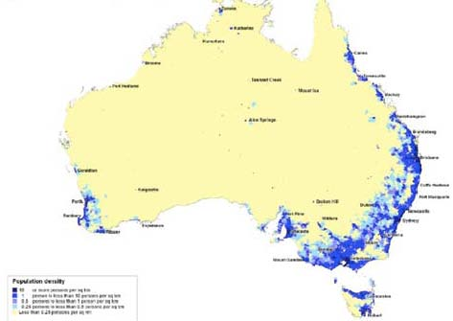
Source: Department of Broadband, Communications and the Digital Economy
The sprawling suburban and regional settings in which most of the population is found make the construction of network infrastructure relatively expensive by world standards. The same demographic challenges led to Australia’s broadcasting system being engineered for wide and uniform coverage. Consequently, cable infrastructure was limited until Optus and Telstra rolled out their hybrid fibre coaxial (HFC) cable networks for subscription (pay) television services in the mid 1990s. Total take-up of cable services is now estimated at around 1 million.
Australia’s generally prosperous and developed economy has benefited from an open and competitive telecommunications market since 1997. Australians tend to adopt technological innovations readily, encouraging suppliers to offer access to new devices and services. These factors have encouraged broadband development.
As a result of the geographical challenges and the high level of interest in communications technology, two key themes emerge as central to the recent Australian story of telecommunications and broadband policy development.
• The first concerns the challenge of encouraging investment in infrastructure while maximising competition especially in areas of relatively low population density.
• The second concerns the challenge of supporting consumer access to widely available, high quality services.

Federal and state powers
The fathers of federation in Australia in the late 1890s assigned powers over ‘telegraphic, telephonic and other like services’ to the new Australian Government. Over time this has meant that the Australian Government has been able to exercise clear responsibility for the regulation of broadcasting, telecommunications and wireless services. However, the six States, the two Territories and the more than 600 local government bodies play an important role in the lives of Australians, particularly in the commercial, agricultural, health, emergency services, energy, transport and education sectors. They are among the largest users of modern broadband and communication services. A national strategy therefore requires the cooperation of all layers of government as well as non-government stakeholders.
Cooperation was critical to many of the funding programs developed in the early stages of broadband promotion. As the focus shifts to rolling out infrastructure in ‘greenfields’ estates, renewing infrastructure in ‘brownfields’ areas, and applying the benefits of broadband infrastructure, the importance of cooperation and the scope for it will only increase.
Regulatory framework and agencies
Under Australian law, regulatory responsibility for communications is allocated largely to
• the Australian Communications and Media Authority (ACMA) and
• the Australian Competition and Consumer Commission (ACCC).
The industry is also encouraged to develop codes and resolve issues where possible, with regulatory intervention as a last resort.
• The ACCC has responsibility for competition and consumer issues across the whole economy. It also has specific powers tailored to the particular challenges of the telecommunications sector. These special powers are concerned with interconnection disputes and access to telecommunications services and facilities, as well as with anti-competitive behaviour in the telecommunications sector.
• The ACMA’s responsibilities encompass a wide range of other regulatory and consumer protection provisions including registration of industry codes, monitoring consumer protections and technical standards, and also monitoring and enforcing Telstra’s compliance with its licence conditions. Other important ACMA functions include numbering, spectrum management, broadcasting regulation and disaster planning.
• The Communications Alliance is an industry body that has prepared most of the registered codes for the industry on matters such as billing, complaint handling, number portability and network standards.
• The Telecommunications Industry Ombudsman is an independent dispute resolution scheme available to consumers and funded by the industry.
• Finally, the Department of Broadband, Communications and the Digital Economy advises the Minister on broad policy matters including the development of legislation, and the agendas for broadband and the digital economy. It also administers some funding programs in support of broad government objectives.

Market structure
ACMA counted 177 licensed telecommunications carriers in its Communications Report 2009-10. Among these Telstra and Optus provide national fixed and mobile services, Vodafone-Hutchison Australia also provides a national mobile network.
A number of regional providers have established their own fibre or cable infrastructure (such as TransACT in the Canberra region and in parts of regional Victoria). Regional operators can resell mobile and other services in order to compete with the large players across a range of services. Many smaller carriers offer specialised services of various kinds, particularly business and information services. Near-complete population coverage has been largely achieved for both fixed and mobile networks.
Table 1: Service coverage, 2010
Services | Coverage | Service providers or networks
Fixed | n/a* | 306 providers (Telstra 82% share**)
VoIP | 2.9 m home users | 204 VoIP providers
Mobile
GSM | 96.2% of population | 3 carrier networks
3G | 99.1% of population | 3 carrier networks
Broadband
Internet | 10.4 m subscribers | 529 Internet service providers
HFC cable | Telstra 2.7 million Optus 1.4 million premises passed | 3 carriers with metropolitan and regional networks (Telstra, Optus, Neighbourhood Cable)
ADSL | n/a | 444 providers
ADSL 2+ | n/a | 177 providers
Fixed wireless | n/a | 164 providers
Mobile wireless | n/a | 161 providers
Satellite | 100% of population | 35 service providers
Sources: ACMA Communications Report 2009-2010 p 23 and Australian Bureau of Statistics
* 2.3 m homes with no fixed phone
** June 2010

Broadband penetration
Figure 2 shows that Australia benefited from relatively strong uptake of household computers and Internet access, with broadband access beginning to grow from around 2004. Compared with other OECD countries, however, Australia’s broadband uptake was relatively slow and the broadband speeds available to users were also slow, with the result that Australia’s ‘ranking’ in OECD reports of broadband uptake generally placed Australia among the lower 50 per cent of OECD members and ITU statistics in 2002 showed that Australia was not among the first movers in the take-up of broadband. The Digital Economy Strategy released on 31 May 2011 noted that OECD statistics show Australia ranked 18th out of 31 countries for fixed broadband subscribers. Australians also pay more for broadband than most OECD countries-for average subscription prices, Australia was the fifth most expensive overall. In hindsight, it appears that the market structure and conditions in Australia were distinctly different from the countries that were the early leaders in the take up of broadband, particularly those with highly concentrated population centres that could be rewired at relatively low cost. There were also some other factors:
Figure 2: Computer, Internet and broadband access
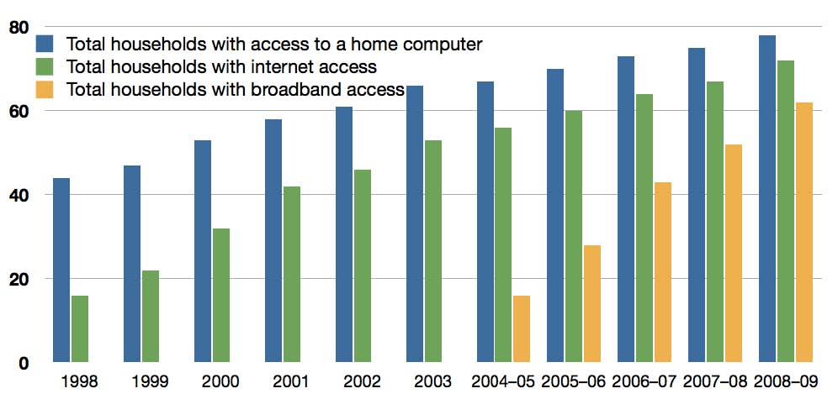
Source: Australian Bureau of Statistics 8146.0 Household Use of Information Technology, Australia, 2008-09

• Broadcasting services provided most Australians with quality free-to-air reception. Cable systems served only a small minority of people with reception problems. Compared to the extensive cable networks in some other developed countries, the small early cable systems in Australia did not provide a platform for infrastructure competition. When hybrid fibre coaxial cable networks were rolled out by Optus and Telstra as a platform for subscription television and data services in 1995 to 1997, Telstra maintained a dominant position in that segment of the market, overbuilding the Optus network to maintain the largest hybrid fibre footprint, and so limiting the prospects for competition to emerge between competing cable and telecommunications networks. Telstra’s position was further strengthened by its 50 per cent interest in Foxtel, the largest pay television service provider. Altogether, including some regional hybrid fibre networks, cable accounts for around 20 per cent of fixed broadband subscriptions, often providing those customers with access to faster data rates than DSL.
• Telstra also dominates the local access copper network. To offer DSL services, competitors must either buy a wholesale DSL service from Telstra or acquire access to the copper line from Telstra’s exchange to the customer’s premises. This can be obtained by acquiring either the Unconditioned Local Loop (ULL) service or the Line Share Service (LSS) from Telstra. As DSL services became an attractive platform for broadband development, regulatory disputes over competitors’ access to unbundled facilities and high prices delayed consumer access.
• The DSL situation changed quite rapidly in 2004 with aggressive price reductions on the part of Telstra and its competitors stimulating the sharp take-off in broadband access from 2004 that is evident in Figure 2. While this was not the end of regulatory disputes, it did bring basic broadband within the reach of many more consumers.
• The short period of rapid construction of hybrid fibre coaxial cable networks serving Australian households came to an end in 1997. Currently DSL services provided over Telstra’s copper network are the dominant mode of fixed broadband access for Australian households.
• Telstra canvassed various options for new fibre to the node investments to support broadband access by consumers, but held back from investing while it sought regulatory concessions that were not forthcoming. On 21 December 2005, Telstra advised the Australian Stock Exchange that the fibre to the node component of its Next Generation Network plans had been placed on hold. On 22 February 2006 it advised the ACCC that “without safeguards to ensure that legacy regulation is confined to legacy services, Telstra will not spend the billions of dollars required to bring higher speed broadband services to those 60 per cent of the consumer base that live greater than 1.5 km from an exchange.”
Competing infrastructure was developed in central business districts and to some extent on major backbone routes, but Telstra remained dominant in the local access network. There is no resale of hybrid fibre coaxial cable access from Telstra or Optus. Telstra have about 42 per cent of fixed broadband subscribers while Optus accounts for about 18 per cent. Most resellers rely on Telstra’s copper network. Nevertheless, within these limitations, broadband access has been growing and NBN Co estimates that fixed broadband revenues now account for over 30 per cent of fixed line revenues.
Figure 3 shows that DSL and mobile are now the most common form of broadband service while dial up access is in the process of disappearing.
Mobile broadband access is increasing rapidly and appears to be a new form of access that is complementing but not displacing DSL or hybrid fibre access. The strong uptake of 3G mobile broadband services reflects the success of the mobile carriers in rolling out 3G mobile broadband services to the extent that Telstra now claims 99 per cent coverage of the Australian population, Optus 97 per cent and VHA (Vodafone-Hutchison Australia) 92-95 per cent. ACMA have reported that 64 per cent of household consumers now have a 3G phone and the mobile market remains competitive, with broadly comparable market shares.
Figure 3: Internet subscribers by technology
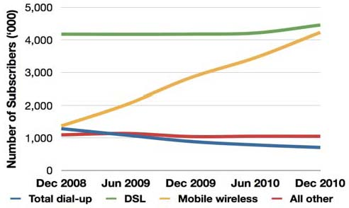
Source: ABS Internet Activity, Australia, Dec 2010 8153.0

Broadband subscriptions, data rates and download volumes
As consumers have responded to more competitive service offerings and benefitted from service upgrades, particularly to ADSL2+, the Australian Bureau of Statistics has observed that the number of consumers with broadband access has continued to grow. Consumers have responded to offers of faster broadband speeds (often with no price increase), and download volumes have increased accordingly. As illustrated in Figure 4, subscriber numbers grew by 17 per cent between 2009 and 2010, while download volumes grew by 50 per cent. Mobile downloads have been reported only since June 2010 and were found to have grown by over 450 per cent in the first six month period. However, this spectacular level of growth comes off a low base. As shown in Figure 5, fixed broadband carried the base load and accounted for 91 per cent of download volume in December 2010 while mobile accounts for only 2 per cent of downloads overall even though mobile broadband subscriber numbers have risen to match DSL subscriber numbers.
Figure 4: Internet connections and downloads
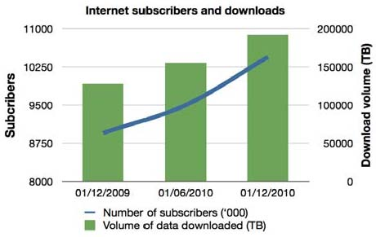
Source: ABS Internet Activity, Australia, Dec 2010 8153.0
A similar conclusion can be drawn from a comparison of Figure 5 and Figure 6 which shows that although 36 per cent of Internet connections are through mobile technology, this accounts for only 2 per cent of download volume. Fixed DSL and hybrid fibre cable, on the other hand, account for 55 per cent of connections and 91 per cent of download volumes, attributable to differences in price and usage patterns between fixed and mobile services.

Figure 5: Downloads- mobile, fixed and wireless
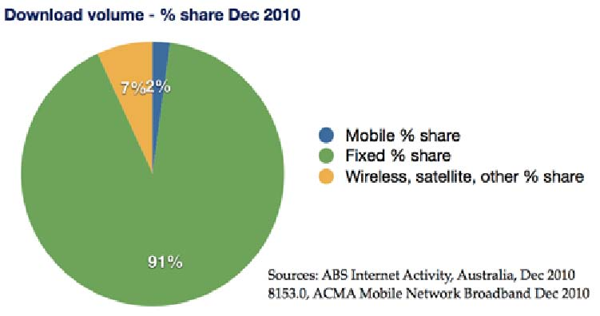
Sources: ABS Internet, Activity, Australia, Dec 2010 8153.0, ACMA Mobile Network Broadband Dec 2010

Figure 6: Internet access technology
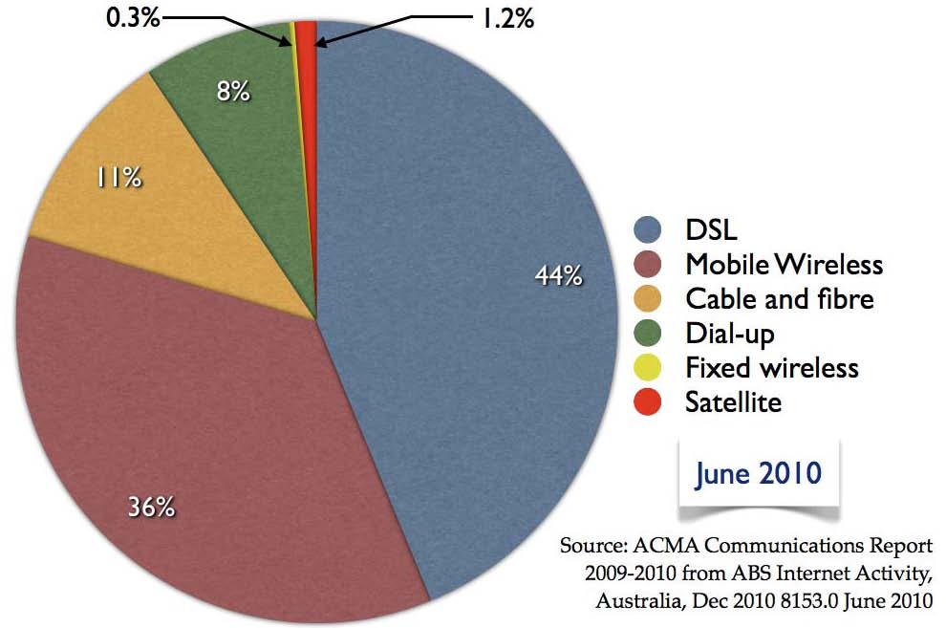
Source: ACMA Communications Report 2009-2010 from ABS Internet Activity, Australia, Dec 2010 8153.0 June 2010
The growth in download volumes reflects the improving affordability of broadband services and a corresponding growth in the take up of services with faster data rates.
Figure 7 shows the take up of services according to the data rates offered. This should be treated with caution, since actual speeds experienced can be very much lower than the nominal rate, especially where there is congestion on a mobile service, or where the DSL customer is distant from the local exchange (see Figure 12). Nevertheless, the shift of consumers from slower to faster broadband appears to be an ongoing process as consumer expectations of online services become more demanding and competing providers make improvements in their service offerings.
In nominal terms, the proportion of consumers with downlink speeds of less than 512 kbps has fallen from 44 per cent in June 2009 to 19 per cent in December 2010. In the same period, the proportion of consumers with access to speeds of 1.5 Mbps and above has risen from 56 per cent to 82 per cent. The rapid growth in download volumes can thus be attributed to consumers upgrading their services to faster speeds as well as to the simple growth in the number of subscribers. Overall, strong growth in demand for improved broadband services shows no sign of abating.
Figure 7: Broadband speeds 2010
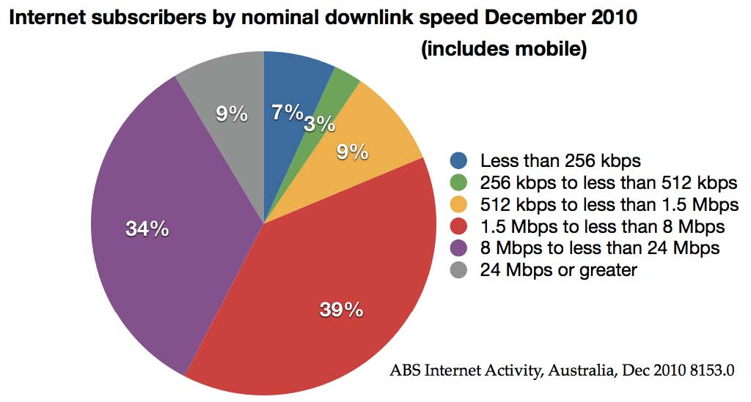
ABS Internet Activity, Australia, Dec 2010 8153.0

Rural and regional services
As described in the case study published in 2009, regional and rural areas have lagged behind metropolitan areas in the take up of broadband services, and the leading program to support rural access in recent years has been the Australian Broadband Guarantee. As from 1 July 2011, that program has been transitioned to the interim satellite service offered by the National Broadband Network and it will be considered further in that context.
Meanwhile, regional and rural services continue to be a priority concern, and on 7 July 2011, the Minister for Broadband, Communications and the Digital Economy, Senator Stephen Conroy, launched the 2011-12 Regional Telecommunications Review that will examine telecommunications services in regional, rural and remote parts of Australia. This will be the second such review after the last review in 2007-8 (reported in the earlier case study).
The committee has been tasked to report on the adequacy of telecommunications services in regional, rural and remote parts of Australia, as well as the opportunities that the National Broadband Network creates in delivering improvements in health and education outcomes, growth in local economies, business efficiencies, and government services and programs. (Regional and other programs supporting the use of broadband are discussed further in section 5 “Broadband prospects, consequences and opportunities.”)

2. Broadband requests for proposals
Proposals for a national broadband network developed through several stages and setbacks before the government announced a commitment in April 2009 to establish a company that would invest up to AUD 43 billion over eight years to build and operate the National Broadband Network. Following is a brief account of the earlier proposals and their outcomes prior to the current National Broadband Network initiative.

2007 broadband request for proposals and outcome
In September 2006, the then Minister, Senator Helen Coonan in the Howard Coalition Government, invited applications for funding large scale infrastructure projects under the Australian Government’s AUD 878 million Broadband Connect Program. In that announcement she said “Several respondents [to an earlier expressions of interest process] are interested in developing proposals for major national or regional infrastructure projects that would result in well developed, end-to-end solutions of significant scale. Some also proposed a consortium approach to bring together major transmission capacity projects (such as interstate links and local access solutions) that could be integrated into comprehensive national or regional projects.”
An expert task force was appointed to manage the assessment process and advise on related issues including regulatory matters. In September 2007 the Minister announced that a funding agreement for a new national high speed broadband network had been signed with OPEL Networks, a joint venture between Optus and the Australian rural group Elders. Overall, this promised a new $1.9 billion competitive broadband network that would deliver high speed broadband to 99 per cent of households and small businesses at retail prices comparable to metropolitan prices. The Elders-Optus joint venture would contribute over AUD 900 million toward the establishment of OPEL Networks. OPEL Networks would be a structurally separated ‘wholesale only’ company that would sell services on a transparent and equivalent basis to parent entities Elders and Optus, and to any other broadband provider in the market. The announcement also said:
• technologies used would include a new wireless broadband network with 1,363 new wireless broadband WiMAX sites across the country, and
• a further 312 exchanges would be enabled with very fast ADSL2+ broadband for the first time, with an additional 114 exchanges being enabled by Optus on a commercial basis.
• 15,000 kilometres of fibre optic backhaul cable would link rural areas back to major city centre.
She also said the government would independently test the network to ensure that coverage was achieved to a very high standard and that service standards were comparable to those in metropolitan areas.
Telstra launched a legal challenge against the Minister over the tender process, but the challenge was dismissed by the Federal Court in October 2007.
Change of government 2007 and termination of contract
After a general election and change of government in November 2007, the new Rudd Labor Government publicly committed to honouring the contract between the Commonwealth and OPEL. However, on 2 April 2008, the Minister for Broadband, Communications and the Digital Economy, Senator Stephen Conroy announced that the OPEL Networks broadband network would not proceed. The announcement said that a “condition precedent of the contract stated that OPEL would provide coverage reasonably equivalent to 90 per cent of under-served premises identified by the then Department of Communications, Information Technology and the Arts as being within its coverage area.”
The Department of Broadband, Communications and the Digital Economy “performed an analysis of the detailed testing and mapping undertaken by OPEL, and determined that the OPEL network would cover only 72 per cent of identified under-served premises,” Senator Conroy said.
“On the basis of [the Department’s] assessment, the government determined that OPEL's Implementation Plan did not satisfy the condition precedent of the funding agreement, and as a result the contract has been terminated.”

2008 National Broadband Network request for proposals and outcome
As part of its 2007 election commitments, the new government had announced that it intended to make available AUD 4.7 billion to facilitate the construction of a National Broadband Network.
On 11 April 2008, the government announced the release of a request for proposals. The request for proposals detailed the scope of the National Broadband Network, which was to:
• deliver minimum download speeds of 12 Mbps to 98 per cent of Australian homes and businesses,
• have the network rolled out and made operational progressively over five years using fibre-to-the-node or fibre-to-the-premises technology,
• support high quality voice, data and video services including symmetric applications such as high-definition video-conferencing,
• earn the Commonwealth a return on its investment,
• facilitate competition in the telecommunications sector through open access arrangements that allow all service providers access to the network on equivalent terms, and
• enable uniform wholesale and affordable retail prices to consumers, no matter where they live.
Proposals closed in November 2008 and an expert panel assessed the proposals.
Termination of process and expert panel advice
The government terminated the process on 7 April 2009 on the advice of the Panel that “none of the national proposals offered value for money.” The Panel also noted the rapid deterioration of the global economy and its impact on the process. An extract from the evaluation report was published, providing further detail on the process and findings. Key points included:
• Telstra had failed to submit a Small and Medium Enterprise Plan as required under the request for proposals leading to its exclusion from further consideration in the process;
• all proposals were to some extent underdeveloped;
• with the right technology and incentives the goal of providing high-speed broadband services to 98 per cent of home and businesses can be reached;
• rolling out a single fibre to the node network is unlikely to provide an efficient upgrade path to fibre to the premises;
• analysis of the proposals had highlighted the importance of competition and the need to improve competition in backhaul supply, particularly in regional areas.
On the same day, the government announced its new proposals for a National Broadband Network, and invited submissions on related regulatory matters.

3. National Broadband Network

National Broadband Network announcement April 2009
The government announced that it would establish a company that would invest up to AUD 43 billion over the next eight years to build and operate an open access wholesale National Broadband Network. The new network would provide fibre optic to the home and workplace, supplemented with next generation wireless and satellite technologies to deliver super fast broadband services.
To turn its vision into action the government immediately took steps to:
• establish a company to build and operate the network and make an initial investment of AUD 4.7 billion in the network;
• commence an implementation study to determine the company's operating arrangements, detailed network design and ways to attract private sector investment;
• fast-track negotiations with the Tasmanian Government, as suggested by the Panel of Experts, to respond to its National Broadband Network proposal and begin the rollout of the FTTP network in Tasmania;
• implement measures to address regional backbone 'blackspots' through the timely rollout of fibre optic transmission links connecting cities, major regional centres and rural towns – delivering improvements to telecommunication services in the short term
• develop legislative changes that will govern the national broadband network company and facilitate the rollout of fibre-to-the-premises networks, including the use of fibre optic technology in future greenfield developments, and
• commence a consultative process on necessary changes to the existing telecommunications regulatory regime

Objectives
The initial objectives stated for the National Broadband Network were to:
• connect 90 per cent of all Australian homes, schools and workplaces with broadband services with speeds up to 100 megabits per second in towns with around 1000 people or more, and
• connect all other premises in Australia (the remaining 10 per cent) with next generation wireless and satellite technologies that will deliver broadband speeds of 12 megabits per second.
The government announced that it would remain a wholesale open-access network. The government also announced its intention to sell down its interest in the company within five years after the network was built and fully operational.

Establishment of NBN Co and development of business plans
The government established NBN Co Limited in August 2009 to build and operate the National Broadband Network. Then on 6 May 2010 the government released a National Broadband Network Implementation Study, prepared by McKinsey & Company/KPMG, that examined the government’s objectives for coverage, commerciality and competition and considered detailed operating arrangements for NBN Co Limited, its ownership and structure, ways to attract private sector investment and longer term privatisation. Key findings of the study included:
• the AUD 43 billion total capital cost of the NBN was a conservative estimate and there were opportunities to significantly reduce the build cost;
• the peak investment required by government was estimated at AUD 26 billion by the end of year seven, of which AUD 18.3 billion would be required over the next four years;
• the fibre component of the NBN should be extended from 90 to 93 per cent and cover the 1.3 million new premises expected to be built by 2017-18;
• NBN Co can build a strong and financially viable business case and could be earnings positive by year six and able to pay significant distributions on its equity following completion of the rollout; and
• the government can expect a return on its equity investment sufficient to fully cover its cost of funds.

Telecommunications reforms announced September 2009
On 15 September 2009, the Minister for Broadband, Communications and the Digital Economy, Senator Conroy announced a number of reforms to promote competition, to address Telstra’s high level of integration and to strengthen consumer safeguards. The draft legislation to implement the reform package was released online. The announcement noted that the proposed reforms were supported by the overwhelming majority of submissions received in response to the National Broadband Network: Regulatory Reform for 21st Century Broadband Discussion Paper released by the government on 7 April 2009.
On the issue of the structure of Telstra, Senator Conroy said:
“It is the Government’s clear desire for Telstra to structurally separate, on a voluntary and cooperative basis.”
“The Government believes it is possible to achieve a win-win outcome in the interests of Telstra, its shareholders and, more broadly, all Australians.”
The legislation was framed in such a way as to allow Telstra to voluntarily submit an enforceable undertaking to the Australian Competition and Consumer Commission to structurally separate. The Minister can provide guidance to the ACCC on the matters it would take into account when considering whether to accept the structural separation undertaking.
If Telstra was to choose not to structurally separate, the legislation provides for the government to impose a strong functional separation framework on Telstra. The legislation developed subsequently introduced a functional separation regime by altering the Telecommunications Act 1997 to require that:
• Telstra conduct its network operations and wholesale functions at arm’s length from the rest of Telstra;
• Telstra provides equivalent price and non-price terms to its retail business and non-Telstra wholesale customers; and
• this equivalence of treatment is made transparent to the regulator and competitors through strong internal governance structures.
The Telecommunications Legislation Amendment (Competition and Consumer Safeguards) Act 2010 prevents Telstra from acquiring additional spectrum for advanced wireless broadband while it:
• remains vertically integrated; and
• owns a hybrid fibre coaxial cable network; and
• maintains its interest in Foxtel.
However, the legislation enables the Minister to remove either or both of the second and third requirements in the event that Telstra submits to the ACCC an acceptable undertaking to structurally separate.
Introducing the legislation in the Parliament, the Minister representing Senator Conroy in the House of Representatives said
“The government retains an open mind on the best model for structural separation as we transition to the NBN.
It may, but does not need to, involve the creation of a new company by Telstra and the transfer of its fixed-line assets to that new company.
Alternatively, it may involve Telstra progressively migrating its fixed line traffic to the NBN over an agreed period of time and under set regulatory arrangements and for it to sell or cease to use its fixed line assets on an agreed basis. This approach will ultimately lead to a national outcome where there is a wholesale only network not controlled by any retail company – in other words, full structural separation in time. Such a negotiated outcome would be consistent with the wholesale only, open access market structure to be delivered through the National Broadband Network.
The government has commenced constructive discussions with Telstra on how NBN Co. and Telstra could work collaboratively towards the NBN. We believe that we can work towards achieving a solution in the national interest that also meets the interests of Telstra and its shareholders.”
The options for Telstra were to undertake a voluntary structural separation of its wholesale and retail operations, or to have a form of functional separation imposed upon it.
Telstra also needed to consider its place in the new broadband environment, with NBN Co the newly established government-owned provider of wholesale broadband services.

Binding agreements on structural separation
With the government having set out the policy framework and broad business options, extensive and complex negotiations were undertaken in the course of 2010 between NBN Co and Telstra which produced first an in-principle agreement between Telstra and NBN Co and then on 23 June 2011, binding agreements that centred upon
• Telstra’s agreement to structurally separate by migrating its fixed line traffic to the National Broadband Network, progressively disconnecting its voice and data services, decommissioning its copper network and migrating its customers to NBN Co, which would become Telstra’s preferred fixed line network.
• NBN Co would be able to utilise existing Telstra exchange space, ducts, conduits and dark fibre to accelerate the fibre rollout and reduce its costs by avoiding the duplication of infrastructure.
Telstra benefits from the deal, not only by meeting the government’s conditions for its continued access to spectrum for advanced wireless services, and for retaining its continued stake in Foxtel, the dominant Pay TV provider in Australia, but also in replacement revenue in the form of disconnection payments as customers are transferred to the National Broadband Network, and other payments for allowing access to its cable ducts and other facilities. Together with payments from the government for universal service related matters (discussed later in this case study) and staff retraining, Telstra has assessed the total payments to Telstra to be around AUD 11 billion (net present value) over a period of 30 years – approximately AUD 9 billion from NBN Co and AUD 2 billion from the Australian Government.
Figure 8: Payments to Telstra
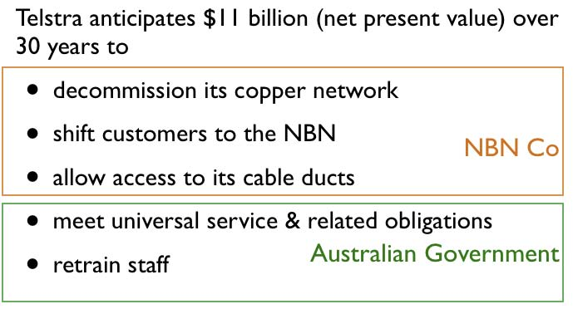
Source: Author adapted from NBN Co and Australia Government

On the same day, NBN Co and Optus announced their AUD 800 million agreement that Optus also would progressively migrate customers to the National Broadband Network. Optus will decommission those parts of its hybrid fibre cable network that do not support mobile infrastructure or its business customers.
Telstra’s hybrid fibre cable voice and data services will migrate to the National Broadband Network, but it will continue to utilise its cable network for Pay TV services.
Together, Telstra and Optus account for 60 per cent of the retail broadband connections in the Australian market.

Open access framework
The newly emerging Australian market will thus be characterised by the structural separation of wholesale and retail services in the fixed line market, particularly in the residential and small business sectors, and by open access arrangements for retailers seeking access to network facilities.
• Telstra, Optus and other providers of consumer services will become wholesale customers of NBN Co,
• NBN Co will remain a wholesale-only business, providing transparent open access to retail service providers, and is developing a Special Access Undertaking. It is being developed to provide NBN Co and its customers with transparency, clarity and regulatory certainty in relation to price-setting to achieve cost recovery. It is also developing a Standard Form of Access Agreement to facilitate access arrangements.
• The Australian Competition and Consumer Commission will be responsible for considering and approving both
– NBN Co’s Special Access Undertaking, and
– Telstra’s Structural Separation Undertakings and Migration Plan.
The nominated ‘separation date’ for Telstra is 1 July 2018. After that date, Telstra will not supply fixed line carriage services to customers using a telecommunications network under its own control. In other words, it will no longer be a vertically integrated fixed line operator. In the meantime, it remains dominant in the market place and Telstra’s Structural Separation Undertaking must also show how, in the interim period, Telstra will provide services to its wholesale customers on an equivalent basis to its own retail business units. These arrangements require ACCC approval, and they must include mechanisms for ACCC monitoring of compliance.
Telstra submitted its proposed Structural Separation Undertakings and Migration Plan to the ACCC on 1 August 2011 and released a high level summary for public information on its web site.

Other aspects of the binding agreements
The new arrangements will not finally be in place until
• Telstra shareholders have given their approval to the binding agreements, and
• the ACCC has approved Telstra’s Structural Separation Undertakings and its Migration Plan.
The agreement also provides for compensation to be paid to Telstra if the National Broadband Network rollout does not proceed after reaching 20 per cent of the proposed fibre coverage area. The compensation amounts to AUD 500 million, diminishing as the rollout extends toward completion.

NBN Co business framework
As NBN Co is established as a Government Business Enterprise, it is subject to legislation covering its governance, reporting obligations and other matters, but two items of legislation are central to its telecommunications operations.
• The NBN Companies Act 2011 limits NBN Co to wholesale operations and establishes arrangements for its eventual privatisation and its subsequent reporting and other obligations.
• The Telecommunications Legislation Amendment (National Broadband Network Measures-Access Arrangements) Act 2011 (the ‘NBN Access Act’) provides a regulatory framework for the National Broadband Network and it includes amendments to the Competition and Consumer Act 2010 to provide that all NBN Co services are subject to ACCC oversight, and to standard access obligations, and to require NBN Co to supply its services on a non-discriminatory basis.
The government provided NBN Co with a Statement of Expectations that guided the company in developing an elaborate Corporate Plan that provides a wealth of detail on the company’s approach to meeting its objectives.
NBN Co is a wholesale service provider. It will supply Layer 2 (‘bitstream’) Ethernet access, not dark fibre on the one hand or more advanced services on the other. Its place in the market is primarily as provider of a new customer access network. Two important questions arose as a result of this positioning in the market:
• Given the government’s requirement that NBN Co provide uniform wholesale access across Australia, should competitors interested only in the more profitable segments of the market (which could thereby undermine NBN Co’s ability to cross-subsidise its less profitable customers) be regulated?
• Given NBN Co’s infrastructure would replace only the customer access network, how many points of interconnection should be provided to retail service providers?
To deal with the possibility of competitors targeting lucrative markets while leaving the remainder to NBN Co, the Telecommunications Act 1997 and Competition and Consumer Act 2010 were amended so that such competitors will be subject to regulatory requirements similar to those applying to NBN Co, thus providing NBN Co with a more level and fairer playing field for operation. Under these laws, fixed-line local access networks built or upgraded after 1 January 2011 so that they are capable of providing speeds of more than 25 Mbps to residential or small business users must be wholesale-only, and the operator of such networks must supply a Layer 2 bitstream service on an open access and non-discriminatory basis. The government has also said that it will consider a levy if necessary to support the national delivery of National Broadband Network outcomes.
Existing 25+ Mbps broadband services and the development of such networks for larger business customers are unaffected by the level playing field provisions. NBN Co’s Corporate Plan assumes that about 4.6 per cent of premises (0.6 million) will be served by non-NBN networks by 2025.
On the issue of how many points of interconnection to offer to retail service providers, NBN Co initially proposed 14 as the least cost option that would also promote retail competition. The matter was referred to the ACCC for advice and after considering submissions the ACCC recommended a ‘semi-distributed’ approach with 121 points of interconnection which were served by at least two competing backbone operators. Given the existence of some competition in the backhaul market and the ACCC’s view that regulatory intervention should be limited to those areas where competition was not present, the approach aims to avoid competitive infrastructure being overbuilt and thereby ‘stranded’. It also limits NBN Co’s overall footprint in the market, particularly in those areas where there is competition.
This outcome is reflected in the NBN Co Corporate Plan.
Against this background NBN Co describes its relationship with its customers in the diagram at Figure 9 which illustrates the place that exists in the market for a wholesaler/aggregator of services.
Figure 9: NBN wholesale and retail business models
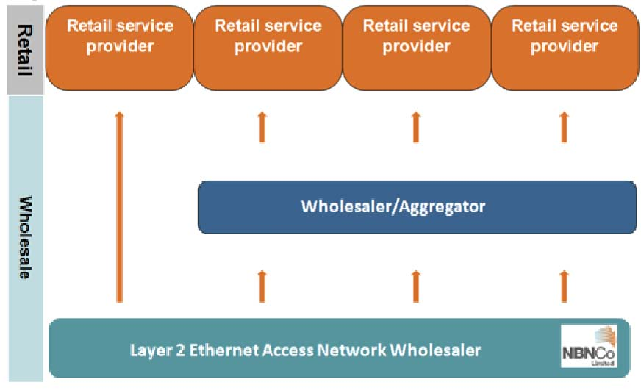
Source: NBN Co. Corporate Plan, December 2010, page 31

Financial estimates
The total capital cost of the rollout of the National Broadband Network is estimated at AUD 35.9 billion. Within this amount, the government expects to contribute AUD 27.5 billion in equity, starting with AUD 3.1 billion in 2011-2012 and the government expects to receive its capital back with interest. NBN Co anticipates a 7 per cent internal rate of return on its funds and expects that from 2014-2015 it can begin raising funds through capital markets totalling AUD 13.4 billion.

Backbone links and transit backhaul
During the early stages of National Broadband Network development, in 2009 the government took steps to roll out a regional backbone blackspots program to cover areas not served by competing carriers with a view to improving regional broadband competition and services as shown in Figure 10. With funding of AUD 250 million, a competitive tender selected Nextgen Networks to build and operate 6000 km of backbone links across six states and territories, reaching over 400,000 people in more than 100 regional locations. The project was completed in December 2011 and is integrated with the broader plans of NBN Co for transit backhaul links shown in Figure 11.
Figure 10: Regional Backbone Backspots Program
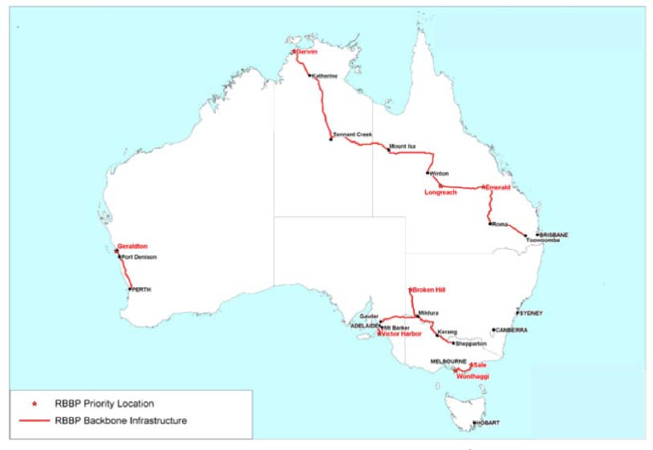
Source: Department of Broadband, Communications and the Digital Economy
NBN Co requires transit backhaul predominantly in rural and remote regions to enable aggregation of communication traffic to a scale required to provide effective and efficient points of interconnect for NBN Co’s wholesale access seekers. The transit network will be a common network used for all three network technologies (fibre, wireless and satellite) and for NBN Co’s own needs for managing the network.

Fibre rollout
The fibre areas covering 93 per cent of the population are marked in red in Figure 11.
Figure 11: Backbone and fibre network
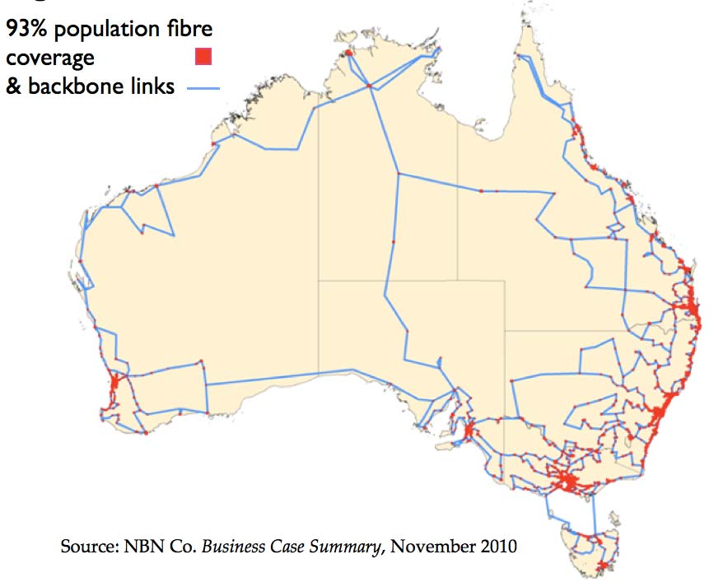
Source: NBN Co. Business Case Summary, November 2010
Over the 9.5 year construction period, NBN Co plans to build or lease 121 points of interconnect and to cover 980 Fibre Serving Areas. There will be a concurrent rollout across multiple regions and coverage will extend to 13 million premises by 2021. NBN Co has estimated that this will require the installation of 181,000 km of gigabit-capable Passive Optical Network (GPON) supported by 57,000 km of transit fibre.
Fibre will also be installed in new ‘greenfields’ developments – estimated at around 2 million premises. Developers are responsible for the pit and pipe infrastructure, and can use any provider they choose. NBN Co is the ‘provider of last resort’ where greenfield developments include more than 100 units. Smaller developments will generally have copper capability provided by Telstra pending NBN Co rolling out fibre. However, Telstra can choose to provide fibre or may provide high quality wireless services as an interim measure.
The fibre rollout began in Tasmania in April 2010 and in five ‘first release’ sites on the mainland in August 2010. In June 2011 a AUD 380 million contract was let with Silcar for major construction in New South Wales, Queensland and the Australian Capital Territory. At its peak, the rollout is expected to pass close to 6000 premises per day. The full rollout is expected to take approximately nine years to complete.
Fibre to the premises is expected to offer a much improved broadband experience to customers as compared with the DSL services that are now widely available, as illustrated by Figure 12.
Fibre will be distributed by underground conduits or by overhead cable, depending on the circumstances, until it reaches an Optical Network Termination device at the customer’s premises.
NBN Co has illustrated their fibre distribution model with the diagram at Figure 13.
Figure 12: ADSL speed and distance
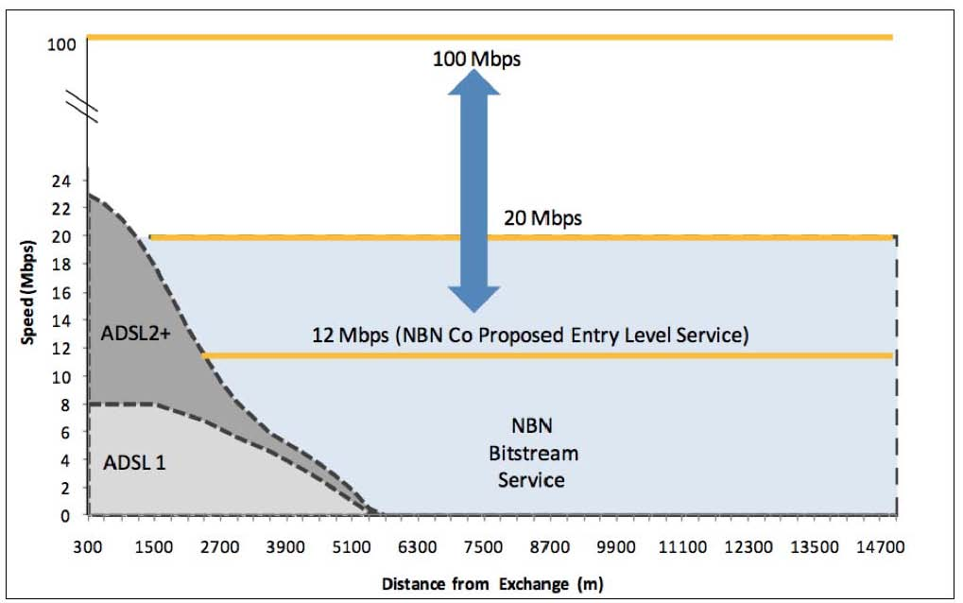
Source: NBN Co. Corporate Plan, December 2010, page 40

Figure 13: Fibre distribution
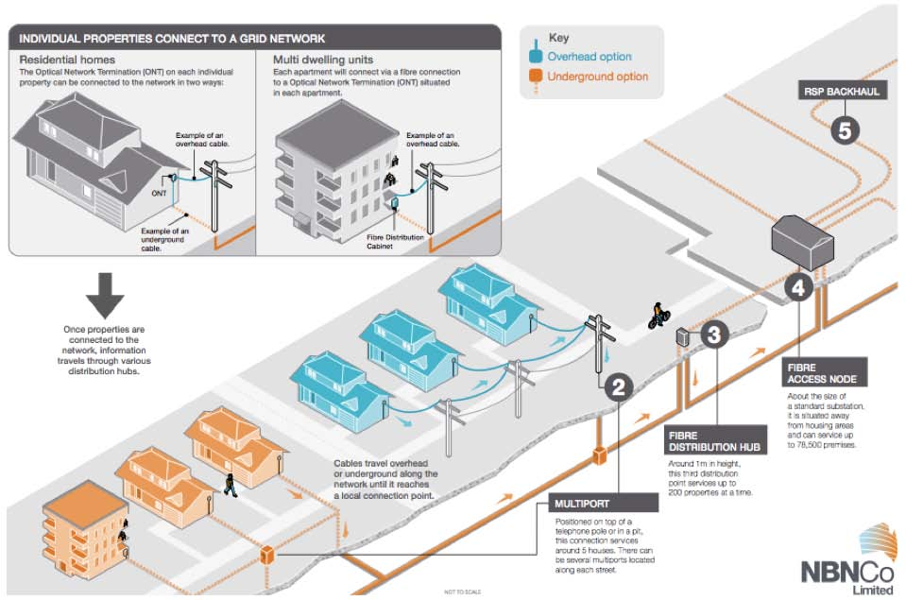
Source: NBN Co. National Broadband Network Information Pack, Chapter 8 ‘Construction’
Fixed wireless broadband
Unlike mobile broadband, the fixed wireless segment of the National Broadband Network will be engineered to meet the speed and service requirements for a known number of users in the coverage area, so that the 4 per cent of users with fixed wireless equipment should have an experience of bandwidth and speed that is much more consistent and stable than mobile services, even in peak times. The fixed wireless broadband service will be delivered to a specific home or business. There will be no hand-over between base stations such as is required on a cellular mobile service.
The starting point for the fibre, wireless and satellite products nationally will be a 12 Mbps downstream/1 Mbps upstream access product enabling retail service providers to offer the same service across all three networks. NBN Co has contracted with Ericsson to design, build and operate the fixed wireless network using LTE technology at a cost of around AUD 1.1 billion. The first service is expected to commence mid-2012 and the network to be completed in 2015.
Australia has a well-established spectrum licensing regime by which a licensee is authorised to use a particular frequency band within a particular geographic area for a period of up to 15 years. Spectrum licences are generally offered at auction for spectrum for which the demand greatly exceeds supply. Spectrum licensees can change their service over time in response to commercial realities, and respond quickly to technological innovation without having to seek government approval. The licences are also fully tradable and can be amalgamated, divided, sold or leased out to third parties, as a whole or in part, based on geographic area, bandwidth or both.
The Implementation Study considered a number of technology options (LTE and WiMAX) and also spectrum options for the fixed wireless element of the National Broadband Network, and the final decisions made by NBN Co appear to reflect similar considerations. They also illustrate the working of the spectrum licensing regime in Australia.
The Implementation Study noted that among 4G options, 3GPP/LTE technology appeared to be favoured by Australian mobile operators. It also observed that, although 700 MHz spectrum offered lower cost technology than other bands, the spectrum was still in process of being cleared of television services and would be unavailable until around 2014. It also appeared to be most useful for mobile and broadband applications other than fixed wireless with its superior in-building capability. The 2.3 GHz band was more readily available and would enable fast deployment of the network.
In February 2011, NBN Co was able to use the option of spectrum trading to purchase 2.3 and 3.4 GHz spectrum across most of Australia from AUSTAR at a cost of AUD 120 million. In July 2011 NBN Co was successful in an ACMA auction in obtaining the 2.3 GHz spectrum it still required in Western Australia and the Northern Territory, completing its national coverage requirements at a cost of AUD 1.3 million. (The auction was competitive with other bidders participating and with no discrimination in favour of the needs of NBN Co). The grey areas marked in Figure 14 represent the proposed coverage areas for fixed wireless broadband services.

Satellite broadband services
NBN Co plans to launch two 80 gigabits per second next-generation Ka band satellites to provide peak speeds of 12/1 Mbps to the 3 per cent of users who remain beyond the reach of both fibre and fixed wireless networks. The satellites, to be launched around 2015 would be used solely for National Broadband Network purposes: not for services such as satellite phones or broadcast television. Multiple high capacity beams illustrated in Figure 15 will be designed for best performance and about 10 gateway sites will be installed across Australia at sites to be determined.

Figure 14: Fixed wireless network
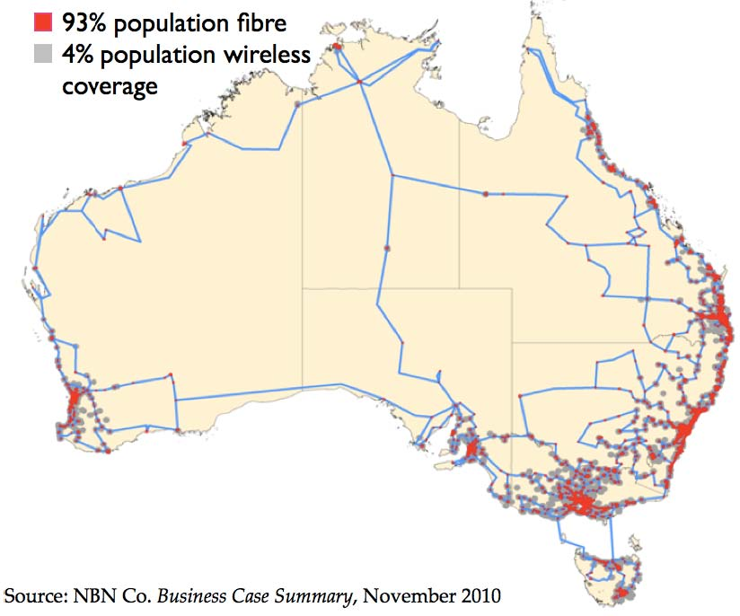
Source: NBN Co. Business Case Summary, November 2010

Figure 15: Satellite network
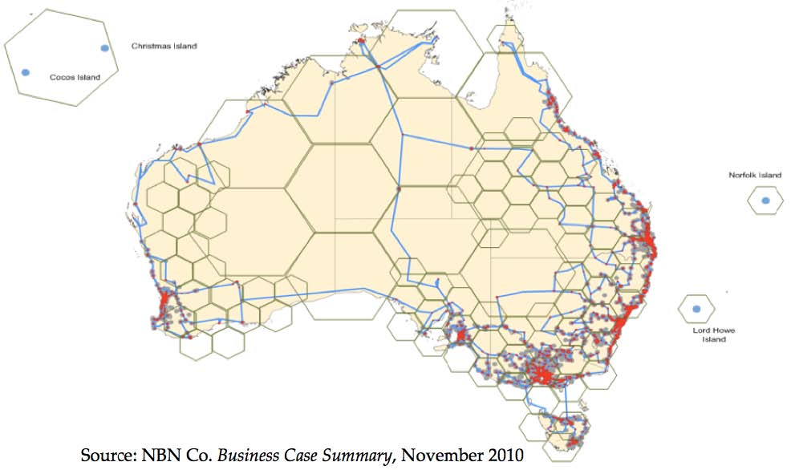
Source: NBN Co. Business Case Summary, November 2010

Interim satellite service
There are long lead times for a new satellite service, so in May 2011, NBN Co contracted with Optus for managed satellite services and capacity, and with IPStar for additional satellite capacity, enabling an interim satellite service to commence from 1 July 2011 with speeds of 6/1 Mbps. Consistent with NBN Co’s mandate and business model, it is a wholesale service. It commenced with four retail service providers with expectations of around twenty by November 2011.
The interim satellite service replaces the Australian Broadband Guarantee program with a change of administration from the Department of Broadband, Communications and the Digital Economy to NBN Co. For clients, the basic criterion for eligibility remains lack of access to a ‘metro-comparable’ service defined as minimum data speeds of at least 512/128 kbps, a 3 GB per month data allowance and a total price to the end customer of no more than AUD 2500 over three years (AUD 70 per month). NBN Co’s wholesale price for a 6/1 Mbps service on the interim satellite service will be AUD 24 per month. Retail offers start around AUD 45.

Wholesale and retail pricing
Looking to the longer term, NBN Co has released its wholesale pricing plan with a common starting point for the fibre, wireless and satellite products being a 12 Mbps downstream/1 Mbps upstream access product enabling retail service providers to offer the same service at this level across all three networks.
Table 2: NBN Co wholesale product pricing
Downstream/ (PIR Mbps) | Upstream / (PIR Mbps) | Fibre (AUD) | Wireless (AUD) | Satellite (AUD)
12 | 1 | 24 | 24 | 24
25 | 5 | 27 | – | –
25 | 10 | 30 | – | –
50 | 20 | 34 | – | –
100 | 40 | 38 | – | –
250 | 100 | 70 | – | –
500 | 200 | 100 | – | –
1000 | 400 | 150 | – | –
Source: NBN Co Corporate Plan, December 2010, page 101

At the time of writing, retail service providers are beginning to announce their retail prices for the stage one rollout of the National Broadband Network on the mainland. In due course, they will be tracked by online websites that compare commercial offers for broadband services, but the initial published prices suggest starting prices for a 12/1 Mbps service with a VoIP telephone service could range from around AUD 34.50 to AUD 59.90 per month with prices for the highest speeds (100/40 Mbps) and largest download allowances from around AUD 100 to AUD 190 per month. Retail prices for National Broadband Network services are generally being set to match existing ADSL 2+ rates where speed and download packages are comparable. (For example, Internode will charge AUD 59.95 per month for an ADSL 2+ package and the same amount for a 12/1 Mbps NBN package including phone service, each with a 30 Gb download quota). This suggests that customers being migrated to the National Broadband Network will not see an increase in prices as they move to a better performing service. They should benefit from competition among retailers in a market where public awareness of the National Broadband Network rollout will help consumers to be better informed about competing services and better able to find price and service offerings that meet their particular requirements.

4. Regulatory reforms and the universal service obligation
In parallel with the 2008 request for proposals process, the government invited submissions on the regulatory arrangements that should apply as Australia moved to a National Broadband Network. This commenced a lengthy and detailed process of consultation on regulatory matters, and the process and outcomes were described in some detail in the 2009 Case Study.
The regulatory decisions outlined in the earlier case study have now been embodied in legislation or other measures.
After receiving eighty two submissions from a wide range of stakeholders, in April 2009 the Minister released a discussion paper to explore options for reform. In his introduction to the discussion paper, the Minister said that the government would consider key options including:
• allowing the ACCC to set up-front access terms and conditions for companies wanting access to Telstra and other networks;
• strengthening the powers of the ACCC to tackle anti-competitive conduct;
• measures to address Telstra’s vertical integration, such as functional separation and also the horizontal integration of fixed-line and cable networks, and telecommunications and media assets; and
• improvements in universal access arrangements for voice telephony and payphones, and the rules around time frames for connections and repairs.
In September 2009, the Minister announced details of the actions the government would take in most of these areas. The outcome on universal service policy became clear only in 2010 and 2011, and so will be treated here in some detail.
The April 2009 discussion paper laid out the government’s plan to achieve a highly competitive telecommunications market and national super fast broadband with the key regulatory issues outlined under two broad headings:
• Proposed regulatory reforms for the NBN rollout, and
• Consultation on broader regulatory reform options.
Most of the regulatory reforms for the National Broadband Network rollout and some of the broader regulatory settings have been embodied in
• the operating regime for NBN Co,
• the National Broadband Network access regime,
• the structural separation arrangements for Telstra,
• the application of market-based spectrum management in the development of the fixed wireless segment of the National Broadband Network,
• the oversight roles of the Australian Competition and Consumer Commission, and
• the arrangements for fibre rollout in new developments.
The outcome in all of these areas has been described in the previous section.
In some respects, however, developments are ongoing. On 10 August 2011, the Minister, Senator Stephen Conroy, released proposed amendments to the Telecommunications (Low-impact Facilities) Determination 1997 and the Telecommunications Regulations 2001 for public comment.
The amendments are to facilitate the timely and efficient rollout of the National Broadband Network, enabling NBN Co and operators of comparable super-fast broadband networks to rely on Commonwealth regulation rather than State and Territory planning laws to:
• connect premises;
• locate equipment in multi-unit buildings; and
• deploy new broadband infrastructure in streets.
Existing protections under the Telecommunications Act would continue to apply so, for example, carriers will still be subject to legal obligations to notify people of intended activity, minimise damage and restore work sites.

Access and competition reforms
When the government consulted on the regulatory issues involved with the move to the National Broadband Network in 2008, the vast majority of submissions that were received focussed on the competition framework. The Department’s discussion paper noted that as of March 2009, the ACCC was considering 51 access disputes, all involving Telstra. Of these, 42 related to the supply of broadband inputs.
Australia has a broad competition and consumer protection law which applies across all sectors of the economy. This is the Competition and Consumer Act 2010. Within that Act, there are provisions specific to telecommunications.
Table 3: Summary of key policy and regulatory challenges
Policy area | Regulatory and other measures | Comments
Structural reform of the telecommunications market | Structural separation and wholesale-only open access and equivalence requirements | Structural separation also a requirement of each major funding initiative since 2007
Investment of public funds | NBN Co to operate on a commercial basis and earn a return on its investment
 | Legislative framework for eventual privatisation of NBN Co | Post-privatisation reporting and other obligations also specified
Network construction | Policy and regulatory framework to support ‘greenfields’ construction | Telstra and Optus migration agreements support ‘brownfields’ conversion
Uniform pricing of wholesale services across Australia | NBN Co uniform national wholesale pricing commitment | Uniform pricing established at the 12/1 Mbps entry level across fibre, wireless and satellite platforms.
 | Open access rules for new consumer networks above 25 Mbps provide a level playing field | A levy could also be imposed if required
Competition policy | Structural separation and wholesale-only open access and equivalence requirements | NBN Co and Telstra (while it remains dominant) are subject to requirements for equivalent and non-discriminatory access
 | Transparency to the regulator of equivalence arrangements | ACCC to approve both the NBN Co Special Access Undertaking and Telstra’s Structural Separation Undertakings and Migration Plan
 | ACCC empowered to set ‘up-front’ access conditions and prices and to deal more speedily with anti-competitive conduct
 | Semi-distributed approach to points of interconnection for retail service providers | Minimises NBN Co footprint in competitive markets
Universal service and continuity of service in the broadband transition | New framework to shift away from imposing regulatory obligations on Telstra to an open, competitive contractual model with a new agency to provide funding in support of standard telephone and payphone access, emergency call service and National Relay Service | Continued focus on standard voice telephone service
 |  | Disability equipment program and Customer Service Guarantee to continue
Spectrum access | Radiocommunications Act provides for spectrum licences and spectrum trading | NBN Co has met its spectrum requirements within the existing spectrum licensing regime

The special telecommunications provisions were adopted because it was thought likely that the standard provisions dealing with anti-competitive conduct and bottleneck facilities may not be up to the challenges of the telecommunications sector, where a ‘damages’ award for refusal to supply access was less important than the supply of access itself. More broadly, telecommunications was seen as an extremely complex, horizontally and vertically integrated industry in which there is considerable scope for incumbents to engage in anti-competitive activity, because competitors in downstream markets depend on access to networks controlled by the incumbent. Anti-competitive behaviour could cause particularly rapid damage to competition in the early stages of competition in the telecommunications market.
The provisions are found in two parts of the Act.
• Part XIC of the Competition and Consumer Act sets out the telecommunications access regime, so that service providers can have access to certain wholesale services from another provider.
• Part XIB sets out a specific anti-competitive conduct regime for the telecommunications sector.
As mentioned earlier, until the National Broadband Network is built and Telstra completes its structural separation in 2018, Telstra will remain dominant in the market place. Telstra’s Structural Separation Undertaking must show how, in the interim period, Telstra will provide services to its wholesale customers on an equivalent basis to its own retail business units. These arrangements require ACCC approval, and they must include mechanisms for ACCC monitoring of compliance. In addition to that, extensive consultation has culminated in changes to streamline both the access provisions and the anti-competitive conduct provisions in the Competition and Consumer Act 2010, reflecting policy announcements made on 15 September 2009. In summary, the reforms:
• allow the ACCC to set ‘up-front’ prices, terms and conditions of access, and binding rules of conduct for regulated wholesale services, and
• enable the ACCC to respond more speedily to anti-competitive conduct, being able to issue a ‘competition notice’ without the consultation that was required in the past.
These changes to the access and anti-competitive conduct provisions deserve some more detailed consideration, as follows.

Access provisions
Since 1997, and under the access provisions in Part XIC of the Competition and Consumer Act 2010, the ACCC has had power to declare specific telecommunications services to be subject to the access regime. Once a service is declared a provider of a declared telecommunications service (an ‘access provider’) is obliged to supply it to another telecommunications service provider (an ‘access seeker’) on request, subject to certain exceptions. The terms on which a declared service is supplied can be determined by
• negotiation and agreement between the parties, or
• if negotiation fails, the terms as set out in an access undertaking previously lodged by the access provider and accepted by the ACCC, or
• in the absence of such an undertaking, a determination by the ACCC following arbitration.
This is sometimes described as the ‘negotiate-arbitrate’ model.
The government concluded that the ‘negotiate-arbitrate’ model was not producing effective outcomes for industry or consumers, so the Act was amended to allow the regulator to set up-front prices and non-price terms for declared services. This will create a benchmark which access seekers can fall back on, while still allowing parties to negotiate different terms.
The ACCC will issue access determinations for each declared service, with terms and conditions (and any appropriate exemptions or special rules) usually set for a period between three and five years. The regulator will also be able to determine ‘fixed principles’, such as how depreciation is treated, to remain in force over a longer period if necessary.
Access agreements entered into between providers and access seekers will have to be lodged with the ACCC, but approval by the regulator will not be required.
The ACCC will have the power to make binding rules of conduct for the supply of a declared service where it considers that there is an urgent need to address problems relating to the supply of the service. The binding rules of conduct are rules that specify the terms and conditions relating to compliance with the standard access obligations. Having such rules in place will allow the regulator to act quickly on issues affecting the supply of retail services.
A number of other streamlining changes to the regime should strengthen regulatory certainty, while facilitating minor modifications to access undertakings. Judicial review is still available, however, for parties wishing to appeal a point of law.

Anti-competitive conduct provisions
Part IV of the Competition and Consumer Act deals with restrictive trade practices and cartel arrangements across the whole economy. Part XIB sets out the additional anti-competitive conduct regime that applies to the telecommunications sector. It prohibits a service provider with a substantial degree of market power from engaging in conduct that has the effect or purpose of substantially lessening competition. (This is broader than the general anti-competitive conduct provisions in Part IV of the Act in which the test for misuse of market power is the purpose of substantially lessening competition).
Under Part XIB of the Act, where the ACCC is of the opinion that anti-competitive conduct is occurring (or has occurred) it can issue a competition notice, which can lead to penalties being imposed if the conduct is proven.
Since the introduction of these measures in 1997, their operation has been criticised by many in industry as being overly protracted, and vulnerable to ‘gaming’ by parties with an incentive to delay or damage new entrants. The legislation made two important changes to the regime:
• The ACCC will no longer have to consult with a party before issuing a competition notice; a process previously prone to delay and obstruction.
• In addition, the reforms will make it clear that the competition notice regime applies not only to carriage services, but also to content services – such as subscription television services – delivered by carriers and carriage service providers.
The competition notice process had been criticised on the grounds that the consultation process prior to the issuing of a competition notice can delay enforcement action. These delays may lead to irreversible damage to the parties that are affected by any alleged anti- competitive conduct. The amendment to the Act therefore removed the requirement for the ACCC to undertake consultation before issuing a competition notice. The intention is that by denying the party alleged to have taken part in anti-competitive conduct the ability to delay the ACCC’s enforcement activities on procedural grounds, both parties should be motivated to resolve the alleged illegal conduct, rather than engage in litigation on procedural matters.
The competition notice can be lifted at any time if the ACCC is satisfied that the allegation of improper conduct is mistaken, or the situation has been corrected.
The amendments to make it clear that the competition notice regime applies to content services delivered by carriers and carriage service providers are intended to deal with an area that had previously been considered uncertain and therefore vulnerable to legal disputation.

Universal service in a broadband environment
The Minister’s announcement of 15 September 2009, which set the framework for much of the regulatory and structural reforms that followed dealt only partially with the issue of the Universal Service Obligation, saying
“Once the detailed operating arrangements for the National Broadband Network (NBN) have been settled, the government will consider the broader range of issues associated with the delivery of universal access. Meanwhile the government will maintain the USO levy at the same rate for this financial year.”
The universal service obligation (‘USO’) is the obligation placed on a universal service provider to ensure that standard telephone services, payphones and prescribed carriage services are reasonably accessible to all people in Australia on an equitable basis, wherever they reside or carry on business. Since 2007-2008 the total USO subsidy has been set at AUD 145,076,237. Telstra remains the primary universal service provider and, given its share of industry eligible revenue, the net annual amount payable to Telstra by other carriers has been around AUD 52 million.
The case study in November 2009 provides an extended account of the creation of the universal service obligation in 1997, its development, the measures to provide for competing universal service providers, debates about the extent to which the obligation might be extended to include data services, and the ongoing contention over the appropriateness of the universal service obligation, its cost and funding. Without repeating all of that, a few points should be made:
• The universal service obligation was originally framed with a vertically integrated basic telephone service in mind.
• Voice has become one of many applications supported by a broadband service – a complete reversal from the days when the telephone service supported a ‘dial-up’ internet service as an optional extra.
• The popularity of mobile telephone services has made any sense of the fixed telephone being either ‘basic’ or ‘universal’ seem increasingly anachronistic.
• In comparison with more modern programs such as the Australian Broadband Guarantee, or the National Broadband Network, the regulatory model of the USO was contentious and difficult to administer.
Nevertheless, it was obvious that with the development of a National Broadband Network, although broadband had not been brought within the regulatory framework of the universal service obligation
• continuity of the standard telephone service was essential in the transition to the National Broadband Network;
• some customers would require nothing more than a standard telephone service; and
• the best way to continue to provide a number of highly valued services required re-examination in the new broadband environment.
One issue to be considered was the continuity of the standard telephone service in the event of a power failure. Unlike the copper network, which carries power to terminal devices, the fibre network will not carry power to enable terminals to continue to function after a mains power failure. NBN Co is planning to install battery backup with the network termination units at the user’s premises, but future replacement, charging and maintenance will not be the responsibility of NBN Co.
Other issues requiring further consideration included
• the future of the payphone service,
• the emergency call service,
• the National Relay Service to support people with impaired speech and hearing,
• arrangements to assist the migration of voice-only customers to a National Broadband Network fibre service as the copper network is progressively decommissioned, and
• some other services such as public alarm systems and traffic lights that had relied upon the public switched network in the past.
A new approach to all these issues was required with the replacement of the copper-based PSTN with a fibre-based broadband environment.
With the 23 June 2011 NBN Co-Telstra agreement, the Australian Government announced a new framework for the universal service obligation and other public interest services as part of the package of agreements between Telstra, NBN Co and the Australian Government.
The package of consumer measures provides for continuity of telephony services in the fibre environment, and it establishes a new framework for universal service policy which will progressively shift
• from a regulatory model – with obligations imposed on Telstra by regulation,
• to an open, competitive and contractual model for universal service provision.
In an accompanying Policy Statement, the government said that the agreements were negotiated on the principles of:
• ensuring continuity of basic universal service outcomes for consumers, taking into account the government’s policy of maintaining reasonable access to a standard telephone service,
• facilitating a transition to greater competition,
• recognising the costs of delivering the services and implementing cost-effective arrangements,
• achieving timely, transparent and definitive outcomes, and
• implementing arrangements that do not impose undue financial and administrative burdens.
The new government statutory agency to manage the regime will be known as the Telecommunications Universal Service Management Agency (‘TUSMA’).
From 1 July 2012 the TUSMA will manage the Government’s agreement with Telstra and will administer contracts and/or grants with service providers with the objective of ensuring that:
• all Australians have reasonable access to a standard telephone service and payphones,
• all Australians have access, free of charge, to an emergency call service (emergency numbers '000', '112' and ‘106’ for the hearing and speech impaired),
• the National Relay Service is reasonably accessible to all persons in Australia who are deaf, or have a hearing or speech impairment, so that they can make and receive calls and to communicate with anyone in the wider telephone network,
• safety net arrangements are in place to assist the migration of voice-only customers as Telstra’s copper customer access network is decommissioned, and
• technological solutions are developed as necessary to support the continuity of public interest services (i.e., public alarm systems and traffic lights).
Under the new framework, the policy objectives for TUSMA will be set out in legislation and TUSMA will then need to take all reasonable steps to ensure that the objectives are achieved. It will do this by entering into contracts and grants.
On 23 June 2011, the government issued a discussion paper on the legislation required to implement these consumer reforms with the deadline for comments being 8 August 2011. As well as outlining the proposed legislative scheme under which the TUSMA is expected to administer agreements with Telstra and other service providers, the discussion paper details the process by which USO regulation would be progressively removed while some other regulatory and administrative arrangements would remain in place including:
• Telstra’s continuing to operate its Disability Equipment Program and to comply with the Disability Discrimination Act 1992, and
• All suppliers of a standard telephone service would continue to be subject to the requirements of the Customer Service Guarantee, and their customers would continue to be able to seek financial compensation under the jurisdiction of the Telecommunications Industry Ombudsman.
After comments had been received and considered, the legislative package was introduced into Parliament on 2 November 2011. The legislative package provides for:
• the establishment, functions, governance and accountability of the Telecommunications Universal Service Management Agency (TUSMA), which will be responsible for entering into and administering service agreements from 1 July 2012;
• the consolidation of two industry levies to fund the delivery of the universal service and other public policy telecommunications outcomes; and
• the introduction of a framework to enable the Minister to remove direct regulatory obligations from Telstra after a transitional period to TUSMA, subject to a number of conditions being met in relation to Telstra's structural separation and contractual and regulatory performance.
The costs of TUSMA will be covered through a combination of dedicated Budget funding and a consolidated industry levy scheme to replace the current universal service obligation (USO) and National Relay Service (NRS) levies. The funding contributions will be based on eligible revenue principles similar to those currently used to determine industry contributions to the USO and the NRS levies. The government will provide dedicated base funding to the TUSMA of at least AUD 50 million per annum for the financial years 2012–13 and 2013–14 and AUD 100 million per annum thereafter.
To facilitate the smooth transition to the new arrangements the government will supplement its base funding for the first two financial years so that the aggregate levy contribution that is made by telecommunications firms other than Telstra will, for the first two years, remain at the amount non-Telstra contributors are assessed as being required to contribute under the USO and NRS schemes for the 2011-12 period.
While the funding details are provided in the Policy Statement, it is the government’s intention to review the industry levy arrangements and the need for any additional Budget funding, over and above the government’s committed base funding, during the course of the first two financial years of the TUSMA’s operation.
The following agreements will be managed by TUSMA in accordance with the proposed TUSMA legislation.
1. Delivery of the Standard Telephone Service Universal Service Obligation
From 1 July 2012, Telstra will have a contractual obligation to ensure standard telephone services are reasonably accessible to all Australians on an equitable basis. Telstra will receive funding to operate and maintain its existing copper network in areas outside of NBN Co’s fibre footprint to provide voice services. Within NBN Co’s fibre footprint, Telstra will be required to act as the retailer of last resort to provide the standard telephone service on request over the NBN fibre network. Telstra will initially be paid AUD 230 million annually.
The term of the agreement is for 20 years. A policy review of the USO legislative arrangements is scheduled to occur before 2018 followed by a review of the contractual arrangements, including the annual payment, for delivery of voice services in 2022.
2. Delivery of the Payphones Universal Service Obligation
From 1 July 2012, Telstra will have a contractual obligation to supply, install and maintain payphones such that they are reasonably accessible to all people in Australia on an equitable basis no matter where they live or work.
Telstra will initially be paid an annual fee of AUD 40 million: an amount that will be reviewed on a five year basis over the life of the contract depending on the number of payphones added and removed.
Again, the term of the agreement is for 20 years. The policy review of the USO by 2018 will also apply to payphones, and there will be a similar review of the contractual arrangements, including the annual payment, for delivery of payphone services in 2022.
3. Migration of voice-only customers
Most customers that are delivered services over a Telstra copper line are expected to take up a National Broadband Network fibre broadband service when their copper line is decommissioned. However, the government recognises that during the transition to the National Broadband Network some customers may want to retain a voice-only fixed line service.
Under the Agreement, prior to the copper network being decommissioned in an area, TUSMA will make available assistance to Telstra to migrate any remaining retail voice-only customers on its copper network that want to maintain a fixed line voice-only service on the National Broadband Network fibre network. These arrangements will also be open to other service providers with voice-only customers.
There are two components of the assistance that will be available from the TUSMA in order to maximise continuity of service for voice-only customers that wish to continue receiving a fixed-line voice service:
• Customer management costs incurred by service providers in advising their voice-only customers of the need to migrate to the NBN or make alternative arrangements in the lead up to copper services being disconnected in an area.
• Connection costs incurred where basic in-home rewiring is required to enable a connection to the NBN for the provision of a voice service.
4. Delivery of the Emergency Call Service
Under the agreement, Telstra will continue to answer and transfer emergency calls to the police, fire or ambulance service in the relevant state or territory in accordance with the regulatory framework. Telstra will be paid an annual fee of AUD 20 million, and will be contracted for up to 20 years to deliver the Emergency Call Service, subject to the outcome of a tender process for delivery of the service which will commence within five years.
To ensure that the Emergency Call Service continues to deliver high quality outcomes, TUSMA will also meet the reasonable costs of any major upgrades to Telstra’s platforms and systems.
5. Development of a technological solution to migrate public interest services from the copper network
To ensure a smooth transition of public alarms and traffic lights from the copper network to an alternative technology platform, such as the National Broadband Network fibre network, TUSMA will fund research and development of an appropriate technological solution to migrate these off Telstra’s copper network. Funding will be limited to circumstances in which there is no technological solution available, being developed or readily adaptable to migrate public alarms and traffic lights.
In the event that a new solution is required, TUSMA may either request Telstra to undertake the necessary research, or engage a third party. Any solution that is funded by the TUSMA will be made available to all service providers on an equivalent basis.
6. New contract management arrangements for the National Relay Service
The TUSMA will assume responsibility for the Commonwealth’s existing contract management functions of the National Relay Service from 1 July 2012. Until then, the Australian Communications and Media Authority will remain responsible for contractual arrangements.
Proposed review
These are substantial changes to the regulatory framework for communications services that are regarded as important for the security and well-being of the Australian population.
The legislation introduced into Parliament therefore provides for a review to be conducted when NBN Co’s network rollout is expected to be well advanced, by 1 January 2018. The scope of the review would include the Telecommunications Universal Service Management Agency Act itself, any legislative instruments made under the Act, and any provisions of the Telecommunications Act 1997 that relate to it. The review would consider (but would not be limited to)
• the extent to which the policy objectives have been achieved,
• whether there should be any changes to the functions of TUSMA, and
• whether there should be any changes to arrangements for the provision of standard telephone services, payphones, emergency call services and the National Relay Service.
The review must make provision for public consultation and the report of the review must be tabled in both Houses of the Parliament.

5. Broadband prospects, consequences and opportunities

Broadband prospects
The exponential growth in computing and communications capacity that has characterised telecommunications and information technology development in recent years is evident in Australia just as much as elsewhere.
Figure 16 shows the rate of increase in download volumes in Australia over recent years. In its Corporate Plan, NBN Co have illustrated the impact of new and emerging uses on household download volumes (Figure 17), moving from a ‘utility’ level of demand of around 6 GB per month through social media (12 GB), full media (50 GB) to more advanced services (200 GB per month). These increases in demand are not attributable to particular ‘killer applications’ but rather to the concurrent use of services and applications that are already available to households or emerging as advanced versions of services and applications that are already in use.
Figure 16: Download growth in Australia 2006-2010
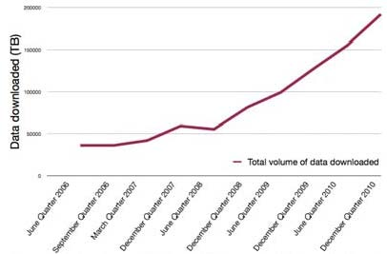
Source: Australian Bureau of Statistics 8153.0 – Internet Activity, Australia, December 2010

Figure 17: Broadband use cases
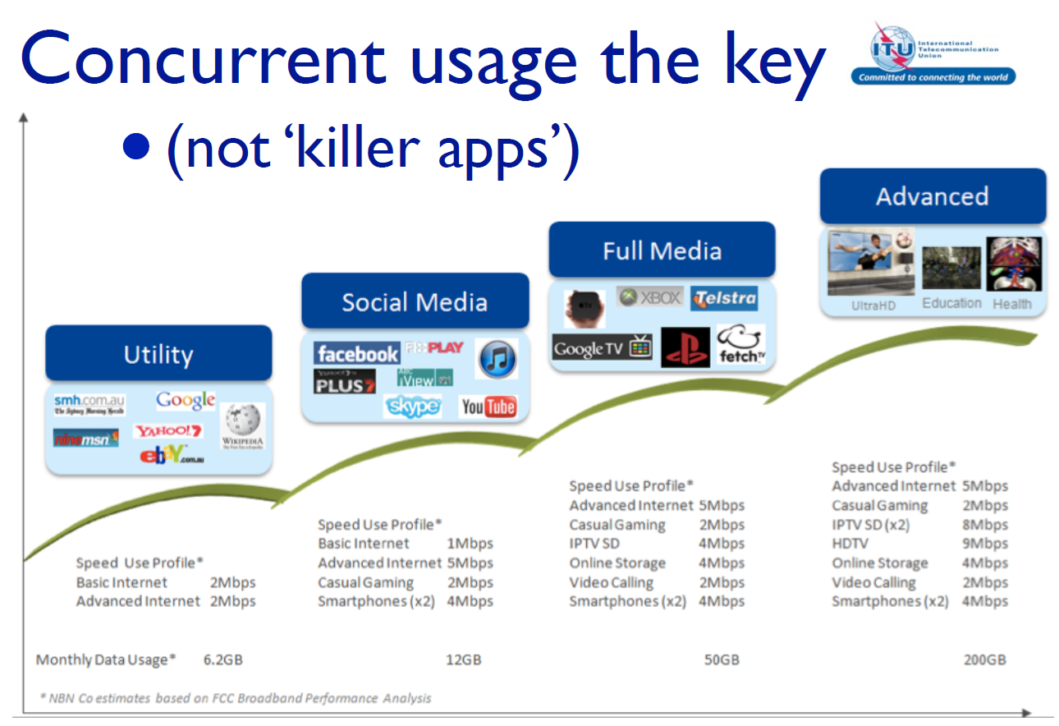
Source: NBN Co. Corporate Plan, December 2010, p 130
Higher speed broadband will provide a discernible improvement in the user’s experience, not only by reducing the time required to download large files, but also to enable participation in high quality real-time audio visual communications.
NBN Co’s Corporate Plan also presents a view from Alcatel-Lucent (Figure 18), showing the logarithmic growth of demand for both fixed and wireless broadband. The graph looks backward as far as 1987 and also offers a forward projection to 2017.
Figure 18: Broadband market prospects
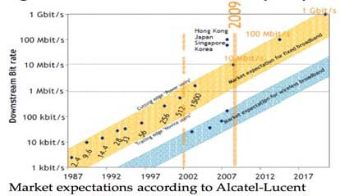
Source: NBN Co. Corporate Plan, December 2010, p 126
On 12 August 2011, NBN Co announced details of a multicast facility to enable delivery of quality video and interactive services by any NBN retail service provider to any fibre-connected consumer. This add-on feature will give retail service providers the opportunity to introduce triple-play voice, broadband and video content to their fibre-based customers. It will have the capacity to provide content such as non-English speaking channels, high-definition television, 3D television, and interactive services.
While the multicast feature will initially be available only on the fibre access network, NBN Co may offer multicast over the wireless and satellite access networks in the future.
Developments such as these present a number of challenges for the communications industry. For policy makers and regulators they represent the ‘convergence’ of previously separate domains of broadcasting, telecommunications and information technology.

Industry challenges
A recent study by the Australian Communications and Media Authority presents an overview of some of the major challenges confronting the communications and media sector in Australia arising from the emerging digital economy and from the ongoing convergence of networks, services and consumer access devices.
It found that the broadcasting and print sectors were both facing audience and readership fragmentation and were responding with a number of strategies including:
• developing online distribution channels;
• attempting to obtain a commercial return for content on the Internet, e.g., pay-per view or ‘premium’ content offerings;
• meeting audience demand for flexibility e.g., catch-up viewing of programs;
• developing video content for devices such as smart phones;
• developing new content sources and a greater variety of content for digital TV, digital radio, IPTV and Internet radio.
Within the telecommunications and Internet sector, the key strategies included:
• bundling voice and content services, such as IPTV, to existing broadband subscribers;
• expanding data download quotas to encourage increased consumption of data services;
• offering more generous mobile caps and pricing packages to encourage the mobile content service market;
• promoting handset innovations and applications e.g., smart phones; and
• offering incentives to customers to retain a fixed-line telephone service.
It may be observed that most of the challenges and threats to the traditional business models come from the proliferation of online and broadband services offered to a customer base that is shared with other media. Equally interesting to note is that most of the responses and strategies adopted by the broadcasting, print and communications industries involve greater use of interactive online and broadband services.
This may go some way toward explaining the dynamism and exponential growth that is currently to be observed in broadband usage.

Convergence Review
The policy and regulatory challenges that arise from these developments are often labelled as issues of convergence – reflecting the fact that regulators and policy makers need a comprehensive framework for dealing with issues that at one time were managed in the previously separate and distinct domains of broadcasting, telecommunications and online services.
When the Minister announced a Convergence Review in December 2010, a background paper was issued that set the scene as follows:
‘Australia's key communications legislative framework was introduced in the 1990s: the Broadcasting Services Act and the Radiocommunications Act were enacted in 1992; the Telecommunications Act was enacted in 1997. Each piece of legislation has been tailored to achieve different public policy objectives.
Our broadcasting legislation was designed to provide flexible regulation to promote objectives such as the availability throughout Australia of a diverse range of broadcasting services that entertain, educate and inform-a broadcasting industry that is efficient, competitive, and responsive to audience needs; and diversity in control of the more influential media services. Specifically, the Explanatory Memorandum for the Broadcasting Services Act 1992 explained the rationale as follows:
it is widely accepted that television is a powerful medium with the potential to influence public opinion, and that television has a role to play in promoting Australia's cultural identity.
Our telecommunications legislation, on the other hand, emphasises the long-term interests of end users of telecommunication services and the efficiency and international competitiveness of the Australian telecommunications industry. And the Radiocommunications Act is designed to promote the efficient allocation and use of spectrum to maximise public benefit.
When the current regulations were being designed, there was little understanding of a future where anyone could easily download a movie to the home TV, view TV programs on a mobile phone, make a telephone call via an Internet service, upload personal videos for all to see, or watch content online whenever they like. In just 20 years, Australia has moved from analog phones to smart phones, from dial-up to broadband, and from five analog free-to-air broadcast television channels to 15 or more digital channels, TV and radio content delivered via Internet, online video and a subscription broadcast industry offering a vast range of television and radio channels from a variety of providers.’
The Convergence Review Committee is to review the current policy framework for the production and delivery of media content and communications services and to develop advice for the government on the appropriate policy framework for a converged environment. On 6 July 2011, the committee released the Convergence Review Emerging Issues Paper which set out its conclusions on key principles, and highlights key issues for further discussion. Comments were sought by 28 October 2011.
The paper notes that new market structures are emerging based on multiple digital platforms and devices and it questions whether regulatory parity is possible or desirable across multiple platforms. For example, can free-to-air content and on-demand content be treated equally? In an online environment, cross-border services present particular challenges, since there is no global policy framework for content.
The paper outlines challenges to traditional licensing, planning and business models in a number of areas including
• broadcast content,
• media diversity and managed market entry arrangements for broadcast services,
• competition law (with an anti-monopoly and anti-competitive behaviour focus),
• content rights,
• community standards and public expectations, and
• spectrum for broadcasting and other services.
All this demonstrates that broadband presents real challenges for the communications sector just as it opens up great opportunities for the wider digital economy.

Digital economy
The challenges for the communications sector need to be considered together with the opportunities that broadband promises for the wider economy. In March 2011, the Department of Broadband, Communications and the Digital Economy presented an extensive submission to a Parliamentary Inquiry in which it considered the national and international evidence of the economic and social potential of broadband provided over a fibre to the premises infrastructure.
It noted that high-speed broadband creates opportunities for business, government and consumers to benefit from improved business opportunities, service delivery, and access.
In particular, high speed broadband has the potential to:
• assist in overcoming the challenges posed by the physical distances people have to travel in regional Australia;
• contribute to an improvement in Australia’s productivity by giving businesses new ways of conducting business and accessing markets;
• allow for better and more efficient use of infrastructure by enabling greater opportunities for tele-working and video conferencing, thereby reducing pressure on transport infrastructure;
• support the growth of the growing “sensor revolution” that allows households and businesses to manage energy consumption;
• support alternative healthcare models which allow patients and the elderly to stay longer at home and reduce pressure on health care budgets associated with an ageing population;
• support enhanced access to education and skills development opportunities; and
• allow governments to enhance service delivery models providing more convenient and more efficient services to clients.
Social inclusion and a number of other potential benefits from online engagement cannot necessarily be measured in economic terms. However, among a number of efforts to quantify the potential savings and benefits to be gained from ubiquitous access to high speed broadband, the report noted:
• Access Economics have estimated the benefits of wide-scale tele-health implementation at between AUD 2 billion and AUD 4 billion per year, while Booz & Co estimated that a shift to e-health would generate a net benefit between AUD 7.5 billion and AUD 8.7 billion to the Australian economy over the first 10 years.
• Access Economics also observed that a 10 per cent increase in Australian employees that telework 50 per cent of the time would save an estimated 120 million litres of fuel, avoiding 320,000 tonnes of CO2 (equivalent to AUD 6 million worth of emissions), and would reduce traffic at peak periods by 5 per cent, resulting in a reduction of AUD 470 million in congestion costs.
• Allen Consulting estimates that if the number of Australian households connected to the Internet increased by 10 per cent, this would provide gains to households of AUD 2.4 billion in terms of consumer surplus. In addition to benefits to households, achieving, for example, a 10 per cent increase in Australians connected to the Internet was estimated to lead to an increase of 0.44 per cent to national GDP.
This naturally introduces the subject of the digital economy, which the Australian Government defines to be:
‘The global network of economic and social activities that are enabled by information and communications technologies, such as the internet, mobile and sensor networks.’
The government’s vision for the digital economy is that ‘by 2020, Australia will be among the world’s leading digital economies based on key indicators such as broadband penetration and usage rankings.’
In support of this vision, on 31 May 2011, the Minister launched the government’s Digital Economy Strategy setting out eight 'Digital Economy Goals' to:
• increase Australian households’ online participation (www.nbn.gov.au/for-households)  • increase Australian business’ and not-for-profit organisations’ online engagement (www.nbn.gov.au/for-business/)  • smartly manage the environment (www.nbn.gov.au/environment/)  • improve health & aged care (www.nbn.gov.au/health-and-aged-care) | • expand online education (www.nbn.gov.au/education/)  • increase teleworking (www.nbn.gov.au/telework/)  • improve online government service delivery & engagement (www.nbn.gov.au/government-services/), and  • increase digital engagement in regional Australia (www.nbn.gov.au/regional-australia/).
The strategy recognises that while the transition to a digital economy is appropriately a market-led phenomenon, it will require action by all levels of governments, industry and the community as a whole on the demand side of the broadband equation.
For its part, the Australian Government has a number of programs and initiatives to support development in areas including
• Digital Communities – to establish a ‘Digital Hub’ in 40 communities which will first benefit from the National Broadband Network to assist residents to develop the skills necessary to participate safely and securely and have trust and confidence in the digital economy. (www.nbn.gov.au/for-households/government-initiatives/digital-communities/)
• Digital Regions Initiative – a co-funding scheme to support innovative digital technology projects with state, territory and local governments.
(www.dbcde.gov.au/digital_economy/programs_and_initiatives/digital_regions_initiative)
• Broadband for Seniors – to develop skills and confidence in older Australians. (www.nbn.gov.au/for-households/government-initiatives/broadband-for-seniors-program/)
• Digital Enterprise – to provide advice and support services to small and medium enterprises and not-for-profit organisations, assisting them to achieve cost savings, productivity enhancements and improved marketing through online engagement. (www.nbn.gov.au/for-business/government-initiatives/digital-enterprise/)
• Online Retail – to highlight the importance of a vibrant Australian online retail sector, in the environment of globalisation and increasing household and business access to the digital economy. (www.nbn.gov.au/for-business/government-initiatives/online-retail-forum/)
• Smart Grid, Smart City – to investigate the synergies of the NBN and other utilities. The Smart Grid, Smart City project, a collaborative initiative together with the energy sector, will roll out Australia’s first commercial scale smart grid. (www.nbn.gov.au/how-the-nbn-will-benefit/environment/smart-grid-smart-city-initiative/)
• Sustainable Australia-managed motorways – to reduce congestion and improve traffic demand management and the overall efficiency of the transport network in major cities. (www.nbn.gov.au/how-the-nbn-will-benefit/environment/sustainable-australia-managed-motorways/)
• Telehealth Trials – to support Australia’s health system to effectively integrate digital technologies and broadband-delivered services to drive efficiency, improve patient outcomes and temper the rate of growth in hospital and other admissions. (www.nbn.gov.au/health-and-aged-care-2/nsw-telehealth-trials-in-kiama-and-armidale/)
• NBN-enabled Education and Skills Services – to promote, develop and trial improved online and interactive education and skills. (www.nbn.gov.au/education/government-initiatives/education-and-skills-program/)
• Telework Forum – to encourage greater adoption of teleworking across all sectors of the economy. (www.nbn.gov.au/telework/government-initiatives/)
• Tell Us Once – to improve people’s ease of use and access to government services and examine the scope for individuals to communicate updated details to multiple agencies simultaneously; pre-fill forms using information previously submitted to a government agency; and view all government communications in one place. (www.nbn.gov.au/government-services/government-initiatives/tell-us-once-initiative/)
These and other government and industry initiatives focus on the users’ knowledge and use of broadband opportunities, endeavouring to accelerate the social and economic benefits to be reaped from the development of the National Broadband Network.

6. Concluding remarks
This case study has reviewed the development of broadband policy in light of the particular circumstances that are unique to Australia.
At its simplest, the policy challenge was how to mobilise large scale investment in high speed broadband and maintain energetic competition in the market, when the cost per user would preclude the duplication of fixed line infrastructure provider in most parts of Australia.
Australia lacked certain features that have enabled broadband development to occur more quickly in some other countries. Some countries have moved ahead quickly where multiple providers of infrastructure have competed to build infrastructure in densely populated areas, and some enjoyed vigorous competition between cable television and telecommunications networks, vying for leadership in the provision of high speed broadband services. Despite some enterprising moves in this direction, hybrid fibre services grew to serve only about 20 per cent of the Australian market and, even then, Telstra was in a position to dominate that segment of the market (and the pay TV services carried by cable) while also enjoying a dominant position in the established fixed telecommunications market.
It was evident on the one hand that a rollout of fibre to the node by Telstra would strand the assets of its competitors, reducing the overall competitive intensity of the market, and strengthening the dominant position of Telstra at all layers of the market for broadband services. On the other hand, Telstra put further fibre investment for consumer broadband access on hold while it sought guarantees that it would not be obliged to make its facilities available to competitors under regulatory conditions it did not accept. Ongoing legal and regulatory struggles over the access regime seemed likely to continue to delay access to improved broadband services.
Successive governments requested proposals and offered substantial sums to stimulate broadband investment, which appeared to have stalled. However, the outcomes of both exercises fell short of expectations: the first process was launched in 2007 with funds of AUD 878 million and the second in 2008 with funds of AUD 4.7 billion.
The last of these efforts encouraged the government to consider a more ambitious approach with a focus on fibre to the premises, with the expert panel advising that a single fibre to the node network was unlikely to provide an efficient upgrade path to fibre to the premises.
By establishing a new entity to rollout fibre to the premises and to provide open access, wholesale-only broadband services in the local access network, the National Broadband Network is changing the structure of the Australian broadband market, changing the incentives for provision of wholesale and retail services and opening up opportunities for competition at the retail services layer.
NBN Co is a commercial undertaking with a mandate to build the network and to provide open access wholesale products with national coverage and uniform national wholesale pricing across Australia treating all retail services on an equivalent basis. Structural separation arrangements should resolve or at least minimise contention over access arrangements enabling the Australian telecommunications market to move to a more streamlined environment for competition regulation.
At the beginning of this study, two key themes were identified as central to the recent Australian story of telecommunications and broadband policy development.
• The challenge of encouraging investment in infrastructure while maximising competition especially in areas of relatively low population density.
• The challenge of supporting consumer access to widely available, high quality services.
The National Broadband Network responds to the first of these themes, providing access to super fast broadband, while the digital economy initiatives in the context of a competitive services market, supported by a modernised broadband-based approach to universal service management responds to the second.
It is in that context that Ministers were able to say to NBN Co, in their Statement of Expectations, that
‘The Government's central NBN objectives are to deliver significant improvement in broadband service quality to all Australians, address the lack of high speed broadband in Australia, particularly outside of metropolitan areas, and reshape the telecommunications sector. The Government recognises that access to affordable, high speed broadband is essential to the way Australians communicate and do business. It will drive productivity, improve education and health service delivery and better connect our cities, regional, rural and remote communities.’
Achieving those objectives remains a multi-year challenge as the National Broadband Network is rolled out.

Appendix 1: Timeline of key developments

Year | Telecom policy developments | USO and regional policy developments | Broadband/Internet developments | Other developments
1991 | Telecommunications Act 1991 | Universal Service Obligation introduced |  | Optus formed with sale of AUSSAT.  Vodafone granted mobile licence
1992 |  |  |  | Telecom and OTC merge to form Telecom Australia (later Telstra)
1993
1994 |  | Broadband Services Expert Group reports, rejecting inclusion of household broadband access in the USO | Broadband Services Expert Group recommends a National Strategy to improve access for schools, libraries, medical and community centres
1995
1996 |  | Review of the Standards Telephone Service recommends inclusion of a digital data capability through the USO mechanism |  | Election of Howard Coalition Government
1997 | Telecommunications Act 1997 introduces open competition  Inclusion of specific telecoms competition powers in the Trade Practices Act | Networking the Nation’ program – the first of a series of initiatives to fund service extension or subsidize consumer access | National Office for the Information Economy established | Sale of one-third ownership of Telstra (T1).  Australian Communications Authority (ACA) formed. ACCC assumes responsibility for competition in the telecommunications sector
1998 |  | ACA inquiry recommends against including a digital data carriage service as part of the USO
1999 | USO provisions amended to provide for a Digital Data Service Obligation. | AUD 314 million ‘Social Bonus’ from T2 funds further programs for regional Australia |  | Second tranche sale increases private ownership to Telstra to 49% (T2)
2000 | Telecommunications Service Inquiry (TSI)  Productivity Commission Review of telecommunications competition regulation | Further funding to improve regional services.  USO regime amended to improve contestability, costing and funding  Minister empowered to determine net universal service cost up to three years in advance | First DSL broadband connections.  Response to TSI includes AUD 50 million for improved dial-up Internet services and AUD 52.2 million National Communications Fund | By November 2000 there were around 696 ISPs and more than 50% of Australian adults were regularly using the Internet
2001 |  | Government response to TSI includes a funding package of AUD 163.1 million to improve telecommunications services in regional and remote Australia | ACCC survey July 2001 finds 122 800 broadband customers:  – 92 500 cable (incl. 86100 residential) – 26,600 DSL (incl. 17 600 residential) – 2300 satellite – 1500 other
2002 | Telecommunications Competition Bill introduces accounting separation regime | Regional Telecommunications (Estens) Inquiry
2003 |  | Government response to Estens inquiry include plans to invest AUD 181 million in response to key recommendations | Broadband Advisory Group report – ‘Australia’s Broadband Connectivity’
2004 |  |  | April – AUD 157.8 million Higher Bandwidth Incentive Scheme (HiBIS) begins, providing ISPs with incentive payments to supply higher bandwidth services at prices comparable to metropolitan areas (ends December 2005)  August – Senate Committee inquiry into ‘Competition in broadband services’ | The National Office for the Information Economy is disbanded with functions distributed to agencies including the Communications, Finance and Industry departments.
2005 | Operational separation of Telstra’s network, wholesale and retail business units | Rules for Telstra local presence. Regular inquiries to review regional services mandated | January – Broadband Connect Incentive Program begins with an incentive scheme to replace HiBIS and Broadband Connect Infrastructure Program to support network construction.  ACCC survey March finds 1 776 800 broadband services in Australia | July – the Australian Communications and Media Authority (ACMA) replaced two former government agencies – the Australian Broadcasting Authority (ABA) and the Australian Communications Authority (ACA)
2006 | Full privatisation of Telstra. |  | ACCC survey March finds 3 161 600 broadband services in Australia  Government seeks expressions of interest to test feasibility of funding larger scale infrastructure under the Broadband Connect program.
2007 |  | USO review begins | April – Australian Broadband Guarantee program begins. Broadband Connect Infrastructure Program contract awarded to OPEL consortium | November Election of Rudd Labor Government
2008 | Digital Data Service Obligation revoked in favour of the Australian Broadband Guarantee | Regional Telecommunications (“Glasson”) Inquiry Report | April – announcement that OPEL contract would not proceed and release of request for proposals to build and operate a National Broadband Network supported by a funding commitment of up to AUD 4.7 billion.  Broadband Network. Australian Broadband Guarantee program extended, bringing total funding to AUD 270.7 million over four years.
2009 | Regulatory Reform for 21st Century Broadband Discussion Paper released on 7 April 2009  September - government announces major reforms to telecom regulation | Preliminary government response to Glasson Review includes announcement of an additional AUD 60 million investment in rural communications.  Preliminary USO reforms announced | April – request for proposals process terminated. Government announces to establish a company that would invest up to AUD 43 billion dollars to build and operate a wholesale-only, open access National Broadband Network.  August – establishment of NBN Co.
2010 | Trade Practices Act 1974 renamed the Competition and Consumer Act 2010 |  | April – fibre rollout begins in Tasmania  May – National Broadband Network Implementation Study  November – NBN Co Business Case Summary released  December – government Statement of Expectations and NBN Co Corporate Plan
2011 | NBN Companies Act 2011 limits NBN Co to wholesale operations.  NBN Access Act 2011 provides that all NBN Co services are subject to ACCC oversight, and to all standard access obligations, and that NBN Co must supply its services on a non-discriminatory basis.  September, – Telecommunications Legislation Amendment (Fibre Deployment) Act 2011 enacted to support deployment of optical fibre infrastructure. | June – government announced reforms to the arrangements for universal service provision  November – universal service reform package of legislation introduced to Parliament | January – fibre in new developments (greenfields) policy comes into effect.  February and July NBN Co obtains spectrum required for fixed wireless network  June – binding agreements between NBN Co and Telstra with Telstra to structurally separate by migrating its fixed line traffic to the National Broadband Network. Agreement also with Optus to migrate customers to the National Broadband Network.  July – NBN Co interim satellite service commences.

Appendix 2: Reports and References
Australian Bureau of Statistics, 8146.0 – Household Use of Information Technology, Australia, 2008-09. (http://abs.gov.au/AUSSTATS/abs@.nsf/Lookup/8146.0Main+Features12008-09?OpenDocument)
Australian Bureau of Statistics, 8153.0 Internet Activity, Australia, December 2010. (www.abs.gov.au/ausstats/abs@.nsf/mf/8153.0/)
Australian Communications and Media Authority, Communications Report 2009-2010. (http://acma.gov.au/WEB/STANDARD/pc=PC_312368)
Australian Communications and Media Authority, Mobile Network Broadband, December 2010. (www.acma.gov.au/WEB/STANDARD..PC/pc=PC_312389)
Australian Communications and Media Authority Communications Report 2009–10 series Report 4 – Changing business models in the Australian communication and media sectors: Challenges and response strategies, 2011.
(www.acma.gov.au/webwr/_assets/main/lib310665/report_4_challenges_and_response_strategies.pdf)
Australian Government, National Broadband Network: Regulatory Reform for 21st Century Broadband, April 2009. (www.dbcde.gov.au/broadband/national_broadband_network/regulatory_reform_for_21st_century_broadband)
Colin Oliver Toward Universal Access to Broadband in Australia, November 2009. (www.itu.int/ITU-D/asp/CMS/Docs/Australia_broadband_case.pdf)
Convergence Review Emerging Issues Paper 2011.
(www.dbcde.gov.au/__data/assets/pdf_file/0020/137270/Convergence_Review_Emerging_Issues_paper_PDF,_707_KB.pdf)
Department of Broadband, Communications and the Digital Economy Extract from the Evaluation Report of the Request for Proposals to Roll-out and Operate a National Broadband Network for Australia, 20 January, 2009.
(www.dbcde.gov.au/communications/national_broadband_network/extract_from_evaluation_report)
Department of Broadband, Communications and the Digital Economy National Broadband Network: Regulatory Reform for 21st Century Broadband, April 2009.
(www.dbcde.gov.au/all_funding_programs_and_support/national_broadband_network/regulatory_reform_for_21st_century_broadband)
Department of Broadband, Communications and the Digital Economy Australia’s Digital Economy: Future Directions © Commonwealth of Australia, 2009. (www.dbcde.gov.au/digital_economy/final_report)
Department of Broadband, Communications and the Digital Economy Convergence Review Background Paper December 2010.
(www.dbcde.gov.au/digital_economy/convergence_review/convergence_review_background_paper.html)
Department of Broadband, Communications and the Digital Economy Submission to the House Standing Committee on Infrastructure and Communications, The Role and Potential of the National Broadband Network, 23 March 2011. (www.aph.gov.au/house/committee/ic/NBN/subs/Sub215.pdf)
Department of Broadband, Communications and the Digital Economy Digital Economy Strategy, May 2011. (www.nbn.gov.au/wp-content/uploads/2011/05/National_Digital_Economy_Strategy.pdf)
Department of Broadband, Communications and the Digital Economy Policy Statement Universal Service in the National Broadband Network Environment June 2011.
(www.dbcde.gov.au/__data/assets/pdf_file/0020/136433/Universal_Service_Policy_in_the_National_Broadband_Network_environment.pdf)
Department of Broadband, Communications and the Digital Economy Discussion Paper 23 June 2011 Universal Service Obligation Legislative Reform for transition to the National Broadband Network. (www.dbcde.gov.au/__data/assets/pdf_file/0018/136431/Discussion_paperUniversal_Service_Obligation_Legislative_Reform_for_transition_to_the_National_Broadband_Network.pdf)
McKinsey & Company and KPMG National Broadband Network Implementation Study. (www.dbcde.gov.au/broadband/national_broadband_network/national_broadband_network_implementation_study)
Ministers Penny Wong and Stephen Conroy Statement of Expectations 17 December 2010. (www.dbcde.gov.au/__data/assets/pdf_file/0003/132069/Statement_of_Expectations.pdf)
NBN Co Business Case Summary, 24 November 2010. (www.alp.org.au/getattachment/64af7c4a-e8b3-4fcd-804c-b3f30b6e11e4/nbn-co-business-case/)
NBN Co Corporate Plan December 2010. (www.nbnco.com.au/news-and-events/news/nbn-co-corporate-plan-released.html)
NBN Co Information Pack. (www.nbnco.com.au/news-and-events/news/national-broadband-network-information-pack.html)

Appendix 3: List of acronyms and abbreviations

3G | Third generation (mobile technology)
3GPP/LTE | 3rd Generation Partnership Project/Long term evolution – the latest standard in the mobile network technology evolution that produced the GSM/EDGE and UMTS/HSxPA network technologies
4G | Fourth generation (mobile technology)
ACCC | Australian Competition and Consumer Commission
ACMA | Australian Media and Communications Authority
ADSL | Asymmetric Digital Subscriber Line
DBCDE | Department of Broadband, Communications and the Digital Economy
FTTP | Fibre to the premises
GB | Gigabyte – a unit of information volume
GHz | Gigahertz (Billion hertz)
GSM | Global Standard for Mobile/Groupe Speciale Mobile
HFC | Hybrid Fibre Coaxial cable
IP | Internet Protocol
IPTV | Internet Protocol television
ITU | International Telecommunication Union
LSS | Line Sharing Service
LTE | Long Term Evolution (3GPP 4G technology)
MB | Megabytes (a measure of data volume)
Mbps | Million bits per second (a measure of transmission speed)
MHz | Megahertz (million hertz)
NBN | National Broadband Network
NGN | Next Generation Network
PIR | Peak information rate
PSTN | Public switched telephone network
TUSMA | Telecommunications Universal Service Management Agency
ULL | Unconditioned Local Loop
USO | Universal service obligation
VHA | Vodafone-Hutchison
VoIP | Voice over Internet Protocol
WiMAX | Worldwide Interoperability for Microwave Access – a telecommunications protocol that provides fixed and mobile Internet access

Australia’s currency has appreciated since the 2009 case study to be around parity with the US dollar.
Prime Minister, Treasurer, Minister for Finance, Minister for Broadband Joint Media Release New National Broadband Network, 7 April 2009 - www.minister.dbcde.gov.au/media/media_releases/2009/022
Colin Oliver Toward Universal Access to Broadband in Australia, November 2009 – www.itu.int/ITU-D/asp/CMS/Docs/Australia_broadband_case.pdf
NBN Co maintains rollout maps on its website showing construction progress in each state and territory. www.nbnco.com.au/our-network/maps.html
ACMA Communications Report 2009-2010, p 23. http://acma.gov.au/WEB/STANDARD/pc=PC_312368
Section 51(v) of the Australian Constitution
A brief outline of the history and structure of telecommunications regulation is available in Appendix F, “Telecommunications Regulation” of the Regional Telecommunications Independent Review Committee Report, September 2008: www.dbcde.gov.au/funding_and_programs/regional_telecommunications_review.
Greenfields’ refers to new developments, usually on the fringe of urban areas in broadacre estates. The term also applies to urban infill and urban renewal developments under the Telecommunications Legislation Amendment (Fibre Deployment) Act 2011. ‘Brownfields’ refers to established areas.
The purchase of TransACT by iiNet was announced on 21 November 2011. www.transact.com.au/en-ACT/about-us/news.
Australian Bureau of Statistics, 8146.0 – Household Use of Information Technology, Australia, 2008-09. The Australian Bureau of Statistics defines broadband as an 'always on' Internet connection with an access speed equal to or greater than 256 kbps and notes that most other OECD countries define broadband in terms of technology (e.g. ADSL, cable etc) rather than speed. http://abs.gov.au/AUSSTATS/abs@.nsf/Lookup/8146.0Main+Features12008-09?OpenDocument.
The ITU Broadband Index placed Australia in 29th place in 2002 Birth of Broadband Report, September 2003. www.itu.int/osg/spu/publications/sales/birthofbroadband/exec_summary.html
Department of Broadband, Communications and the Digital Economy Digital Economy Strategy (www.nbn.gov.au/wp-content/uploads/2011/05/National_Digital_Economy_Strategy.pdf) May 2011, quoting Broadband subscribers per 100 inhabitants in OECD countries (www.oecd.org/document/23/0,3746,en_2649_37441_33987543_1_1_1_37441,00.html) last updated 6 December 2010 and OECD Broadband Prices Monthly Subscriptions, Oct 2009 (www.oecd.org/document/54/0,3746,en_2649_34225_38690102_1_1_1_1,00.html)
Telstra’s partners are Consolidated Media Holdings and News Corporation, each with a 25 per cent investment in Foxtel. A proposed merger with Austar (the other leading pay TV provider) is currently under consideration by the ACCC.
ULL is the use of unconditioned communications over copper wire pairs between the boundary of a telecommunications network at a customer’s premises and a point of connection with a service provider usually other than the owner of the unconditioned network.
LSS involves an access provider providing a voiceband PSTN service to an end-user, whilst providing access to another carrier (the access seeker) to simultaneously provide services to the same end-user over the high frequency portion of the unconditioned local loop. Access seekers typically use the LSS together with their own network equipment to supply DSL services to end-users.
An account of this phase of development is available in OECD Working Party on Telecommunication and Information Services Policies, 7 Nov 2003, “Broadband and Telephony Services over Cable Television Networks”, pp25-27. www.oecd.org/dataoecd/24/59/18807949.pdf
Telstra Corporation Limited Submission to the Australian Competition and Consumer Commission “Response to the ACCC Proposal – “A strategic review of the regulation of fixed network services” February 2006 page 22. www.accc.gov.au/content/item.phtml?itemId=726728&nodeId=68553e96521649eace75bf83ade01f48&fn=Telstra.pdf
NBN Co Corporate Plan December 2010, p 35. www.nbnco.com.au/news-and-events/news/nbn-co-corporate-plan-released.html
Source: ACMA Mobile Network Broadband, December 2010, page 20. www.acma.gov.au/WEB/STANDARD..PC/pc=PC_312389
Telstra 41%, Optus 33%, VHA 26%. Source: ACMA Communications Report 2009-2010, p 33. http://acma.gov.au/WEB/STANDARD/pc=PC_312368
Colin Oliver Toward Universal Access to Broadband in Australia, November 2009. www.itu.int/ITU-D/asp/CMS/Docs/Australia_broadband_case.pdf
Senator the Hon Stephen Conroy, ‘Rosemary Sinclair to Chair 2011 – 2012 Regional Telecommunications Review’ Media Release 8 July 2011. www.minister.dbcde.gov.au/media/media_releases/2011/213
Senator the Hon Helen Coonan, Minister for Communications, Information Technology and the Arts, Media Release 21 September 2006 $600 million Broadband Connect program launched. www.minister.dbcde.gov.au/coonan/media/media_releases/$600_million_broadband_connect_program_launched
Senator the Hon Helen Coonan, Minister for Communications, Information Technology and the Arts, Media Release 9 September 2007 New OPEL Project Underway. www.minister.dbcde.gov.au/coonan/media/media_releases/new_opel_project_underway
Computerworld, “Telstra's OPEL lawsuit dropped” 12 October, 2007. www.computerworld.com.au/article/200879/telstra_opel_lawsuit_dropped/
Senator the Hon Stephen Conroy, Minister for Broadband, Communications and the Digital Economy Media Release 2 April 2008 OPEL Networks Funding Agreement not to proceed. www.minister.dbcde.gov.au/media/media_releases/2008/019
Senator the Hon Stephen Conroy, Minister for Broadband, Communications and the Digital Economy Media Release 11 April 2008 Government invites National Broadband Proposals. www.minister.dbcde.gov.au/media/media_releases/2008/023
Extract from the Evaluation Report of the Request for Proposals to Roll-out and Operate a National Broadband Network for Australia, 20 January, 2009. www.dbcde.gov.au/communications/national_broadband_network/extract_from_evaluation_report
Prime Minister, Treasurer, Minister for Finance, Minister for Broadband Joint Media Release New National Broadband Network, 7 April 2009
www.dbcde.gov.au/communications/national_broadband_network/national_broadband_network_Regional_ Backbone_Blackspots_Program
www.dbcde.gov.au/broadband/national_broadband_network/fibre_in_new_developments
www.dbcde.gov.au/communications/national_broadband_network/regulatory_reform_for_21st_century_broadband
McKinsey & Company and KPMG National Broadband Network Implementation Study released 6 May 2010 on Department of Broadband, Communications and the Digital Economy web site. www.dbcde.gov.au/broadband/national_broadband_network/national_broadband_network_implementation_study
Minister for Broadband, Communications and the Digital Economy, the Hon Stephen Conroy Media Release Historic reforms to telecommunications regulation 15 September 2009. www.minister.dbcde.gov.au/media/media_releases/2009/088
Structural separation had been a requirement of both the 2007 and 2008 broadband requests for tender, as outlined in the previous section. The concept was not new. This was different, however, in being applied to Telstra as a stand alone requirement.
The Hon Anthony Albanese, Minister for Infrastructure, Transport, Regional Development and Local Government, Telecommunications Legislation Amendment (Competition and Consumer Safeguard) Bill 2009, Second Reading Speech, 15 September 2009
For details of the estimated value of the various payments, see Telstra Corporation Media Release 23 June 2011 Telstra Corporation Signs Definitive Agreements. www.telstra.com.au/abouttelstra/media-centre/announcements/telstra-signs-nbn-definitive-agreements-2.xml
Telstra Media Release 1 August 2011 Telstra lodges Structural Separation Undertaking and Migration Plan with ACCC. www.telstra.com.au/abouttelstra/media-centre/announcements/Telstra-lodges-Structural-Separation-Undertaking-with-ACCC
Ministers Penny Wong and Stephen Conroy Statement of Expectations 17 December 2010. www.dbcde.gov.au/__data/assets/pdf_file/0003/132069/Statement_of_Expectations.pdf
NBN Co Corporate Plan Dec 2010. www.nbnco.com.au/news-and-events/news/nbn-co-corporate-plan-released.html
Source NBN Co Information Pack. www.nbnco.com.au/news-and-events/news/national-broadband-network-information-pack.html
Source NBN Co Information Pack. www.nbnco.com.au/news-and-events/news/national-broadband-network-information-pack.html
National Broadband Network Implementation Study May 2010, page 304-308. www.dbcde.gov.au/broadband/national_broadband_network/national_broadband_network_implementation_study
Together with its predecessor, the Higher Bandwidth Incentive Scheme (HiBIS), the Australian Broadband Guarantee operated from 1994 to 2011. Customers of the Australian Broadband Guarantee retain their rights to standards of service and pricing for a period of three years.
The NBN Co webpage on satellite services provides a link to the updated list of retail service providers. www.nbnco.com.au/our-network/fibre-wireless-satellite/satellite.html
Source: NBN Co. Corporate Plan, December 2010, p 101. NBN Co notes that Wireless and Satellite pricing for 12/2Mbps and 12/4Mbps pricing is under review and that, over time, the company expects the cost of higher speed tiers to be reduced in nominal dollars terms.
Initial prices have been announced by Exetel (www.exetel.com.au/), Internode (www.internode.on.net/) and iinet (www.iinet.net.au/nbn/) and Optus. Websites comparing broadband prices include Whirlpool (http://bc.whirlpool.net.au/), Compare Broadband (www.comparebroadband.com.au/), iSelect (http://comms.iselect.com.au/broadband/), WhistleOut (www.whistleout.com.au/) and youcompare (http://broadbandguide.com.au/).
Colin Oliver Toward Universal Access to Broadband in Australia, November 2009, pages 32-42. www.itu.int/ITU-D/asp/CMS/Docs/Australia_broadband_case.pdf
Department of Broadband, Communications and the Digital Economy National Broadband Network: Regulatory Reform for 21st Century Broadband, April 2009. www.dbcde.gov.au/all_funding_programs_and_support/national_broadband_network/regulatory_reform_for_21st_century_broadband
The package dealt with both vertical integration arrangements and with issues of horizontal integration by drawing together the issues of structural separation and the competition restrictions on Telstra’s continued access to advanced mobile spectrum and its continued interest in Foxtel.
The Department of Broadband, Communications and the Digital Economy also maintains a comprehensive web page on these and related regulatory developments. www.dbcde.gov.au/broadband/national_broadband_network/telecommunications_regulatory_reform
Senator the Hon Stephen Conroy, Minister for Broadband, Communications and the Digital Economy, Media Release 10 August 2011 Proposed regulatory changes to support NBN rollout. Comments were due by 7 September 2011. www.minister.dbcde.gov.au/media/media_releases/2011/233
Department of Broadband, Communications and the Digital Economy National Broadband Network: Regulatory Reform for 21st Century Broadband, April 2009, page 13. The discussion paper reflects views of Telstra and its competitors on various aspects of the competition regime. www.dbcde.gov.au/all_funding_programs_and_support/national_broadband_network/regulatory_reform_for_21st_century_broadband
On 1 January 2011 the Trade Practices Act 1974 was renamed the Competition and Consumer Act 2010.
This is not the whole of the competition regime. Other measures that support competition in the Australian market include • the accounting separation and operational separation rules applying to Telstra, • the telecommunications facilities access regime under the Telecommunications Act 1997 (www.austlii.edu.au/au/legis/cth/consol_act/ta1997214/) which allows access to facilities such as exchanges, pillars, ducts and towers, and • Provisions in the Radiocommunications Act 1992 (www.austlii.edu.au/au/legis/cth/consol_act/ra1992218/) that permit restrictions on the allocation of spectrum to support competition in the market.
Minister for Broadband, Communications and the Digital Economy, the Hon Stephen Conroy Media Release Historic reforms to telecommunications regulation 15 September 2009, page. www.minister.dbcde.gov.au/media/media_releases/2009/088
Colin Oliver Toward Universal Access to Broadband in Australia, November 2009, pages 11-17. www.itu.int/ITU-D/asp/CMS/Docs/Australia_broadband_case.pdf
Contestability was introduced, but without attracting competing bids. Other strategies for providing rural services were adopted. For example, the Australian Broadband Guarantee provided an economical solution to the provision of ‘metro-comparable’ broadband service, and it also had the merit of attracting competitive participation from a number of market players.
As explained in the earlier case study, in 1999 there was a move to expand the USO to cover narrowband data services by means of a Digital Data Service Obligation. This was repealed in 2008 having been made obsolete by other broadband developments, and the USO approach has not been expanded to mobile and broadband internet services.
The “standard telephone service” is a core concept in the telecommunications regulatory regime. It is a communications service for the purpose of voice telephony that is able to connect with any other service of the same type. This broad definition means that a standard telephone service can be delivered by a range of communications networks.
This requirement was an item in Ministers Penny Wong and Stephen Conroy Statement of Expectations 17 December 2010. www.dbcde.gov.au/__data/assets/pdf_file/0003/132069/Statement_of_Expectations.pdf
The Hon Julia Gillard, Prime Minister, Senator the Hon Stephen Conroy, Minister for Broadband, Communications and the Digital Economy, Senator the Hon Penny Wong, Minister for Finance and Deregulation, Joint Media Release 23 June 2011, Government and Telstra agree on package of consumer measures. www.minister.dbcde.gov.au/media/media_releases/2011/204
Policy Statement Universal Service in the National Broadband Network Environment June 2011. www.dbcde.gov.au/__data/assets/pdf_file/0020/136433/Universal_Service_Policy_in_the_National_Broadband_Network_environment.pdf
Joint Media Release 23 June 2011, Government and Telstra agree on package of consumer measures. www.minister.dbcde.gov.au/media/media_releases/2011/204
www.dbcde.gov.au/policy_and_legislation/responsibilities_under_the_telecommunications_act/emergency_call_ services
Triple Zero (000) is Australia's primary emergency service number with 112 available also only from GSM mobile phones. Telstra, as the designated universal emergency call service provider, currently operates the Triple Zero emergency call service from two centralised emergency call centres in New South Wales and Victoria. Telstra's role in operating the Triple Zero service is to connect callers to the nearest and most appropriate emergency service organisation as quickly as possible. The local emergency service organisation (police, fire or ambulance) is then responsible for sending help to the correct location.
www.dbcde.gov.au/telephone_services/information_for_people_with_disability/national_relay_service
People who have a hearing or speech impairment or are deaf can access the service through the use of equipment for text-based communications including tele-typewriter, tele-braille or computer with a modem connected through the National Relay Service. The service is confidential and is provided at no additional cost above the cost of a standard telephone call to consumers and it has a dedicated text-based emergency call service-106. More information is on the Australian Communications and Media Authority website. www.dbcde.gov.au/telephone_services/information_for_people_with_disability/national_relay_service
Department of Broadband, Communications and the Digital Economy Discussion Paper 23 June 2011, Universal Service Obligation Legislative Reform for transition to the National Broadband Network environment. www.dbcde.gov.au/__data/assets/pdf_file/0018/136431/Discussion_paperUniversal_Service_Obligation_Legislative_Reform_for_transition_to_the_National_Broadband_Network.pdf
Under the Customer Service Guarantee, telephone companies must pay financial compensation to customers where certain minimum performance standards are not met. Minimum standards under the Customer Service Guarantee include the time frames for connecting new services, rectifying faults and keeping appointments. If a phone company fails to meet the standard, it must pay the affected customer specified financial damages. Typically, this is paid in the form of a credit on the customers bill.
Department of Broadband, Communications and the Digital Economy web site Universal Service Policy in the National Broadband Network environment. www.dbcde.gov.au/funding_and_programs/national_broadband_network/universal_service_policy
Under the Agreement, Telstra remains subject to the Telstra-specific retail price controls. However, with Telstra’s commitment to make use of the NBN fibre network to provide the standard telephone services the Government has stated that it recognises that at this time Telstra does not have complete certainty as to the future nature of the Telstra specific retail price controls and hence the prices that it can charge for the provision of the standard telephone service.
The government expects that the need for re-wiring will be limited given that NBN Co will endeavour to install its equipment in locations that will enable ready access by customers and that its equipment will include an in-built telephony port so that customers can directly connect existing phones. All in-home rewiring work will be undertaken by qualified installers and will be arranged through a customer’s retail service provider. This assistance is intended to provide a safety net to ensure that voice-only customers receive assistance to migrate to NBN Co’s fibre network prior to Telstra’s copper network being disconnected.
NBN Co Media Release 12 August, 2011, NBN to deliver quality video and interactivity to consumers and business. NBN Co has released an information paper for industry with more details, and is seeking industry feedback. NBN Co plans to release the multicast feature to the market in the middle of 2012 following a testing period due to begin at the end of 2011. In the interim, service providers will be able to make IPTV and video on demand services available through the uni-cast capability of the network. www.nbnco.com.au/assets/media-releases/2011/multicast-12-aug-11.pdf
ACMA Communications Report 2009-10 series Report 4 – Changing business models in the Australian communication and media sectors: Challenges and response strategies, 2011, page 3. www.acma.gov.au/webwr/_assets/main/lib310665/report_4_challenges_and_response_strategies.pdf
Department of Broadband, Communications and the Digital Economy Convergence Review Background Paper December 2010. www.dbcde.gov.au/digital_economy/convergence_review/convergence_review_background_paper.html
Convergence Review Emerging Issues Paper 2011. www.dbcde.gov.au/__data/assets/pdf_file/0020/137270/Convergence_Review_Emerging_Issues_paper_PDF,_707_KB.pdf
Department of Broadband, Communications and the Digital Economy Submission to the House Standing Committee on Infrastructure and Communications, The Role and Potential of the National Broadband Network, 23 March 2011. www.aph.gov.au/house/committee/ic/NBN/subs/Sub215.pdf
Access Economics, Financial and externality impacts of high-speed broadband for telehealth, May 2010. www.dbcde.gov.au/digital_economy/benefits_of_digital_economy_from_nbn
Booz & Co, E-health: enabler for Australia’s health reform, prepared for the National Health and Hospitals Reform Commission, November 2008. www.racgp.org.au/Content/NavigationMenu/ClinicalResources/ehealth/Resources/Booz_eHealth_Report.%20pdf
Access Economics, The Impacts of Teleworking Under the NBN, 2010. (www.dbcde.gov.au/__data/assets/pdf_file/0018/130158/ImpactsofteleworkingundertheNBN.pdf) The Bureau of Transport and Regional Economics estimated that in 2005 the social costs of congestion across Australia’s capital cities equalled about $9.4 billion. This figure is based on costs associated with people’s loss of private time, loss of business time, extra vehicle operation and extra air pollution. The Bureau estimates these costs will double during the 15 years between 2005 and 2020 to $20.4 billion (Bureau of Transport and Regional Economics. Estimating urban traffic and congestion cost trends for Australian cities (Working Paper No 71), 2007. www.btre.gov.au/publications/56/Files/wp71.pdf
The Allen Consulting Group, Quantifying the economic gains of getting more Australian households online, page 39. November 2010. www.dbcde.gov.au/__data/assets/pdf_file/0004/135508/Quantifying_the_possible_economic_gains_of_getting_more_Australian_households_online.pdf
Department of Broadband, Communications and the Digital Economy Digital Economy Strategy, May 2011. www.nbn.gov.au/wp-content/uploads/2011/05/National_Digital_Economy_Strategy.pdf
Ministers Penny Wong and Stephen Conroy Statement of Expectations 17 December 2010. www.dbcde.gov.au/__data/assets/pdf_file/0003/132069/Statement_of_Expectations.pdf

