Regulation and consumer protection in a converging environment
March 2013

This report has been prepared for ITU by Rosalind Stevens under the direction of the BDT Regulatory and Marked Environment division.

Please consider the environment before printing this report.

© ITU 2013
All rights reserved. No part of this publication may be reproduced, by any means whatsoever, without the prior written permission of ITU.

Foreword

It is my pleasure to introduce the report on the regulation and consumer protection in a converging environment, in the framework of Resolution 64 of the World Telecommunication Development Conference (Hyderabad, 2010) and the activities of ITU-D Study Group 1. I have championed that ITU-D work closely with its Membership on this topic: to help them develop good policy; to create partnerships for ICT investment; and, to build human capacity.
The expansion of digital technologies has dramatically changed the way in which electronic communication services are delivered to and accessed by consumers. Broadband networks, voice, data and video services can now be offered on the same platform. This not only promotes competition of a wide variety of services and applications that was not possible before, but consequently requires new regulatory frameworks to tackle issues previously managed in the separate and distinct domains of broadcasting, telecommunication and online services.
This report describes and analyses the various resources, strategies and tools that regulators need to improve the enforcement of national laws, rules and regulations governing consumer protection in a converging environment.
I hope that the guidelines, recommendations and best practices for the implementation of consumer-protection policies related in this report will assist today’s multi-stakeholder efforts to address many issues affecting present and future economic and social development.

Brahima Sanou
Director, Telecommunication
Development Bureau

Table of contents
Page
Foreword i
Table of contents iii
Introduction 1
Section 1: Current regulatory frameworks in relation to consumer protection. 1
Section 2: Defining the problem – what does convergence mean for regulation and consumers? 6
Section 3: Critical areas for the establishment of policies or regulatory frameworks for the
protection of consumers and users in a converging environment 8
Section 4: What are the organisational methods and successful practices used by NRAs to
enforce their national laws, rules and regulations governing consumer protection in a converging environment? 16
Section 5: Guidelines and recommendations for successful methods and practices for meeting
the challenges of convergence 19
Section 6: Summary and conclusions 21

Introduction
With the introduction of Internet Protocol (IP) and broadband networks, voice, data and video services can now be offered on the same platform. This convergence has enabled inter-platform competition for a wide variety of services and applications that was not previously possible. As a result, ‘traditional’ telephony providers now offer video and data (Internet) services, and cable companies offer Internet access and voice services. Wireless networks that previously provided mainly voice services have now become the primary means of Internet access in many countries.
Convergence has had the following impact on services, networks, devices and companies:
• Services: voice, data and video services and applications can all be provided over a single infrastructure platform.
• Networks: different types of transmission systems (wire line, wireless, satellite, unlicensed) can be linked together through IP to deliver converged services anywhere and at any time.
• Devices: a single device can allow access to telephone services, video streaming or broadcasting and Internet access.
• Companies: firms are combining in many different ways through mergers and acquisitions and vertical integration in order to respond to consumers’ demands for advanced services.

Section 1: Current regulatory frameworks in relation to consumer protection.
In July 2012 the ITU-D Study Group 1 conducted a survey on consumer protection policies amongst its 193 member states, focusing on convergence. The findings will help to inform conclusions of ITU-D Study Group 1 Question 18-2/1 for the 2010-2014 study period.
A total of 37 complete entries were received in response, including two from regional/international organisations and two from sector members. Figure 1 below illustrates the regional breakdown of respondents. Table 1 breaks down respondents according to development status.
Figure 1: Regional breakdown of survey respondents

Source: ITU

Table 1: Breakdown of responses by development status
 | Percentage
Developed countries | 18.9
Transition countries | 2.7
Developing countries | 54.1
Least Developed countries | 21.3

Out of the 32 responses received from member states 67 per cent reported having specific legislation for consumer protection and consumer rights for telecoms/ICT consumers. By contrast, only two out of eight of respondents from Least Developed Countries (LDCs), Senegal and Mali have such legislation.
Where legislation exists, the most commonly cited consumer related provisions are: access to information/transparency; quality of service; equity/right of access to services; protection of personal data; privacy; confidentiality of information and the right to complain.
Less commonly cited rights were:
• The right to end/change a contract (7/29, 24%)
• Compensation in case of service interruptions (5/29, 17%)
• Right to block advertisements (4/29, 14%)
• Access to Emergency Numbers (3/29, 10%)
• Portability of phone numbers (3/29, 10%)
Survey respondents reported almost universal provision for consumers to have access to pricing/rates information for fixed, mobile, and Internet access and services (for personal computers and smart phones). Twenty-three of the survey respondents (62%) reported playing a role in the investigation of consumer complaints.
Consumer complaints play a valuable role in helping regulators to identify those areas where current legislation/regulation may be lacking and where best to target intervention. The most commonly reported type of complaint, cited by all survey respondents, were about pricing and billing; quality of service; and service outages/poor coverage.
A key indicator of successful consumer protection practices is the time taken to resolve consumer complaints. This helps demonstrate the level and cost of resource required and identifies which agency is best placed to handle the complaints. Amongst those National Regulatory Authorities (NRA) that reported having a role in complaint handling, there was a fairly even distribution of the time taken to resolve the complaint. Around two thirds were resolved within 25 days. Three out of 16 respondents reported facing problems and challenges with slow complaint procedures.
As Figure 2 illustrates, there is considerable variation between developing and developed/transition countries in the type of consumer protection responsibilities undertaken. For example, regulators in developed countries are less likely to play a direct role in complaints handling than those in developing countries, with responsibility for fraud protection most prevalent in least developed countries.
Figure 2: Consumer regulation activities by development status
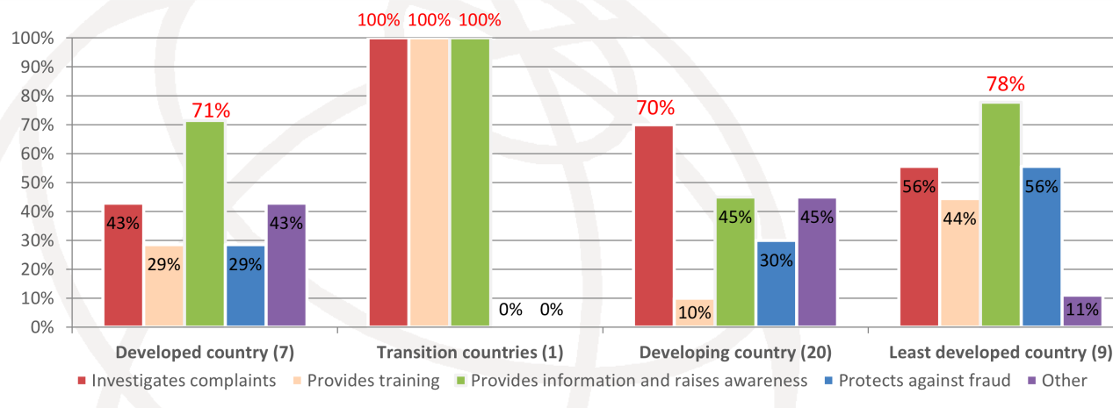
Source: ITU

Out of the 13 per cent of total telecommunication regulatory authorities (TRA) who reported having no specific consumer protection legislation, 10 out of 17 have an alternative NRA that is empowered to apply general consumer protection regulations to the telecoms/ICT sector.
Figure 3: National Consumer protection regulatory authorities with a remit that extends to telecoms/ICT
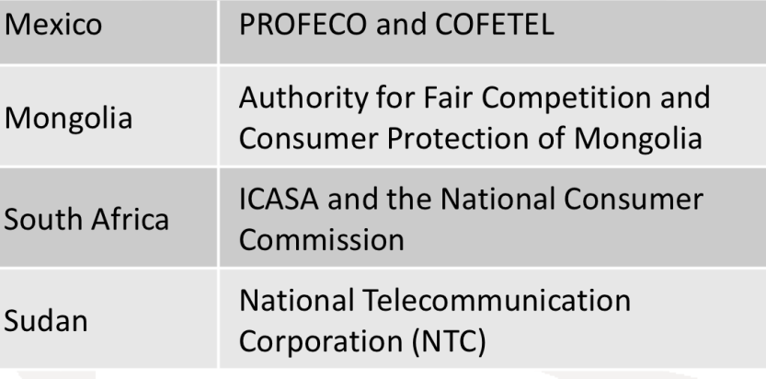
Source: ITU

In almost two thirds of respondent countries, only one or two agencies are involved in consumer protection, but in the remaining third there are three or more. Respondents reported considerable variation in the type of consumer protection for which those agencies are responsible. In the majority of cases the agency in question has some responsibility for consumer education and complaints: around three quarters play some role in drafting legislation and just over one half have a role in law enforcement.
Figure 4: ICT/Telecom related responsibilities of consumer protection agencies
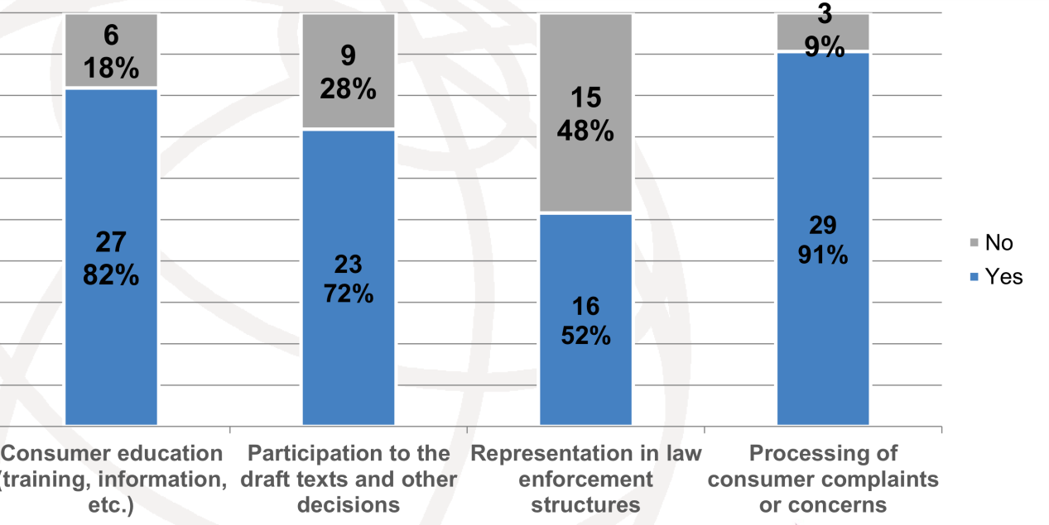
Source: ITU

Half of the respondents reported difficulties experienced by the agencies in enforcing consumer law and/or encouraging consumer protection in some form. This proportion rose to three quarters amongst LDC respondents.
Many respondents reported that the consumer protection agencies had structural problems including a lack of expertise and human resources. Other respondents said their consumer protection legislation was inadequate or non-existent. There were also problems around consumer education and awareness.
Whereas in the majority of cases respondents reported a clear division of responsibilities between the different agencies involved, just under one third reported some overlap in competencies. Where this exists, only around one half of respondents said they had the means with which to actively share information about the challenges faced. Where information is shared this is either through official information sharing agreements, special papers and reports, workshops or through a government ministry.
Around the same proportion said they co-operated or co-ordinated with consumer protection agencies on a ‘needs’ only basis. This may explain why only half of respondents believed consumers found it easy to know which agency to contact for different matters. On the other hand, this response seems to contradict the survey finding that just over two thirds of consumers can solve their problems concerning converged services by contacting one agency. There was an almost even split between respondents who agreed that consumers should apply to different entities for their specific problems.
For the most part the telecoms/ICT regulator nevertheless felt able to resolve individual telecoms/ICT related consumer protection issues itself, without referring the consumer to another agency.
Over half of all survey respondents felt that some additional legislation to protect consumers was needed in their country, with almost two thirds reporting that consumer needs were not being served appropriately by existing legislation, or that legislation was out of date. Almost three quarters of respondents felt they needed more guidelines and recommendations on consumer protection – including how to educate consumers and keep them informed.
Few respondents reported updates made to consumer legislation in their country (19 respondents). Where this had taken place, it had been within the previous two years in over half of respondent countries (59 per cent) and covered a number of different areas including:
• new user rights;
• increased information/transparency;
• data security/privacy; price regulation; and
• accessibility.
Of those respondents reporting unique reforms, these included consumer protection guidelines (Bahrain), telecommunication employee regulation (El Salvador) and a new complaint resolution system (Senegal).
A very small number of respondents (6 of out of 33) reported implementation of regulatory changes to accommodate different aspects of converging services. The measures were diverse, with the only areas of overlap being price transparency (three out of eight) and technology/net neutrality (two out of eight).
Unique responses included:
• Customer communication regulations – sales of bundled services (Colombia)
• Contract regulations (Colombia)
• Pay TV regulatory framework (Brazil)
• Protection of personal information (Italy)
• Convergence of spectrum usage (Uganda)
This is a surprisingly low number given the high prevalence of converged services reported in all respondent countries:
• 79 per cent have VOIP services;
• 52 per cent have IPTV/mobile TV services;
• 14 per cent have mobile payment/banking services;
• 21 per cent have ‘other’ converged products and services including mobile GPS-localization services; smart phone and tablet services; combos (pay TV, telephone and internet broadband); double play (broadband and fixed line services); triple play (broadband, fixed and restricted TV services) and total play (broadband, fixed, mobile and restricted TV services).
ITU data shows that at the end of 2012 there were still 158 separate telecom/Information and Communication Technology (ICT) regulators worldwide – albeit many have seen their mandates expand over the past five years to include information technology and broadcasting. Telecom/ICT regulators are responsible for regulation of Internet content in only around 16 per cent of countries (mainly in Africa, Arab States and Asia-Pacific), although this is double the amount reported in 2009. Telecoms/ICT regulators have broadcast regulation as part of their mandate in 18 per cent of the countries.
Figure 5: Mandate of Regulators, worldwide, 2012
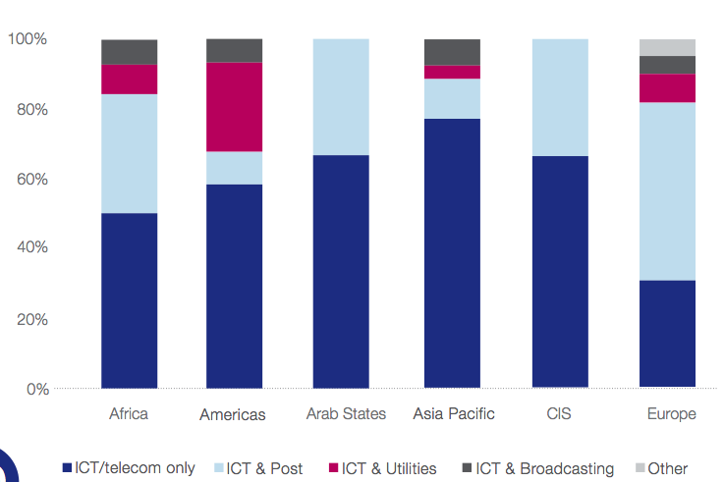
Source: Trends in Telecommunication Reform Report 2010/2011

A few member states have started to move towards a converged regulatory framework by merging telecommunication and broadcasting regulatory authorities into a single converged ICT authority. The converged regulators’ responsibilities include consumer protection, competition oversight and industry specific regulation. Some also have a specific mandate to guarantee a certain level of consumer protection and education alongside promoting a level playing field and monitoring quality of service.
Overall the survey findings demonstrate a general lack of resource, strategies and tools available to protect consumers in a rapidly converging environment.

Section 2: Defining the problem – what does convergence mean for regulation and consumers?
As outlined in the Introduction, the expansion of digital technologies and the Internet, particularly Web 2.0, has dramatically changed the way in which electronic communication services are delivered and accessed. This presents regulators with a number of challenges. These include:
• Encouraging investment in high-speed networks and advanced technological solutions that are universally available and accessible.
• Protecting innovators, creators and consumers from counterfeiting and piracy associated with the online (increasingly cross-border) distribution of goods and services
• Promoting and safeguarding E-commerce: by creating a framework in which reliable and efficient electronic payment mechanisms (card, internet and mobile) can flourish (e.g. e-identification and trust services for e-transactions).
• Ensuring consumers have all the information they need to make informed choices and have adequate protection and redress mechanism if things go wrong.
• Safeguarding trust in the Internet by developing a robust cybercrime strategy and data protection and privacy strategy that is future proofed to cope with new technologies.
• Creating a simpler, clearer regulatory framework and level playing field for distributors of content, avoiding legal uncertainty, duplication and double monitoring that may occur where network and transmission regulation is separate from content regulation.
High-speed reliable networks
A reliable infrastructure offering improved connectivity and speed is central to the successful delivery of converged services that match consumers’ expectations. This is why governments across member states are actively promoting the use and development of broadband as a vehicle for economic and social development and growth. This helps businesses and consumers to conduct their businesses both domestically and internationally, promoting digital products, services and physical products. By the end of 2011, fixed broadband services were commercially available in 206 economies; and mobile broadband services (3G and 4G) in 160 economies.
On-line counterfeiting and piracy
The Internet has provided counterfeiters and pirates with a new and powerful means to sell their products via auction sites, stand-alone e-commerce sites and email marketing. The development of new technologies also poses a challenge for the prevention of the unauthorised use of protected works and the principle of copyright as the means to reward the development of and investment in creative content.
Promoting and safeguarding e-commerce
Consumers want easy access to the goods and services they buy online, including purchases made through their mobile devices. They also want assurance that their data is safe and not being used for irresponsibly or fraudulently. Trust is essential for promoting e-commerce and cross border online trade but regulation has to be proportionate and sufficiently flexible to accommodate future innovation.
Keeping consumers informed and providing redress if things go wrong
Government, regulators and industry need to ensure consumers have access to clear information and education about converged services so they can make informed choices. Consumers need to understand the type of content they are accessing and the level of regulation it is subject to. Regulators need to find ways to protect consumers from harmful content and provide access to redress, particularly as services are increasingly delivered from outside national boundaries.
Safeguarding trust in the Internet
Internet traffic is doubling every 2-3 years and mobile Internet traffic every year. It is predicted that by 2015 there will be 25 billion wirelessly connected devices globally; doubling to 50 billion in 2020; and mobile data traffic will increase 12 fold between 2012 and 2018, data traffic on smart phones by 14 times by 2018. The downside of the increase in traffic is the rising threat of cybercrime, and risks to network security. Trust in the Internet may be compromised by inappropriate use of personal data or risks to the security of online data.
Figure 6: The devices which people are using to access the Internet 2012
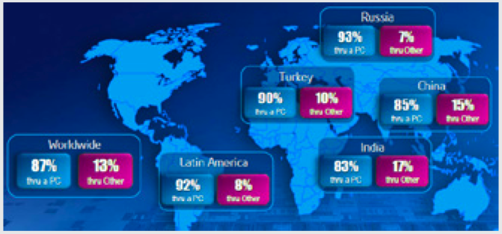
Source: Intel, published in “The Device Wars”– in State of Broadband Report

Creating a simpler, clearer regulatory framework
The overall aim of regulatory policies and regulations to safeguard the public interest and protect consumers should be to create an environment in which high quality; sustainable converged communications services can flourish. This includes developing and maintaining a consistent level of consumer protection across different digital media environments. Having thriving legitimate online markets benefits businesses and consumers alike. Thus when considering consumer protection policies, regulators need to assess the potential impact of regulatory intervention, in terms of new or additional burdens on business, as compared with the potential benefits for consumers.

Section 3: Critical areas for the establishment of policies or regulatory frameworks for the protection of consumers and users in a converging environment
Modifications to regulatory frameworks, including improved measures around enforcement and implementation of legislation, rules, and regulations to protect consumers are needed because:
• Service providers that previously served different markets are now competing for the same customers.
• There are significant and on-going changes in how services, applications and content are provided and sold to consumers.
The challenge for all regulators is to understand the underlying dynamics of convergence from a consumer perspective. For consumers, convergence is not some abstract concept that concerns networks, providers and devices – it relates to and impacts upon their behaviour and the nature of their relationship with their service provider. Consumers are able to interact seamlessly with their community of choice in ways that suit their own personal preferences – in terms of device, timing, mode and medium. For example, under the umbrella of Web 2.0, many sites enable users to share multimedia content, data, experiences, views and opinions on different issues, and even to act cooperatively to solve global problems. In short, the traditional ‘consumer’ is shifting to becoming a ‘prosumer.’
From a service provider perspective, prosumers are a source of valuable user data that enables user profiling, opinion mining, trend and crisis detection, and collective problem solving. Although the prosumer may be willing to transfer and exchange vast amounts of personal data online for their own needs, they may nevertheless feel entitled to protection against the misuse of that information including the right to be better informed about their rights and be in more control of that information. The prosumer also continues to face a number of constraints in terms of pricing, choice, technical complexity, device incompatibility, service terms, and so on.
Although few member states have already established policies and/or regulations to accommodate converging services, the areas in which they have chosen to intervene include on price transparency and technology/net neutrality. This rationale appears to be supported by the most commonly reported types of complaint cited by all survey respondents, which were around pricing and billing; quality of service; and service outages/poor coverage.
Other important consumer rights cited by respondents were the protection of personal data/privacy/confidentiality of Information (9/29, 31%) and the right to complain (8/29, 28%).
Net neutrality and quality of service issues
The expression “net neutrality” usually refers to the debate around whether there should be an overarching principle of non-discrimination regarding different forms of Internet traffic carried across networks.
The net neutrality debate is typically argued from a supply-side perspective (i.e. whether network operators should be allowed to block or charge for prioritising an application provider’s traffic). The actual and potential massive increases in data traffic as consumers use more services and applications increases pressure on network capacity and breaks down the traditional links between end use and the associated costs of service provision.
Although consumers may be prepared to pay more for faster Internet speeds and the ability to access new content and applications, unless they are able to differentiate between the various service offerings, there is considerable potential for dissatisfaction, particularly if the quality of service is degraded or content is blocked.
The challenge for regulators is to balance a consumer’s demands for unlimited access and unrestricted content against a provider’s ability to use the bandwidth available effectively and resist the temptation to block Internet applications and content to try and control the pipeline, restrict competition and limit consumer choice.
In 2010 the Italian NRA, AGCOM, undertook an investigation into traffic management techniques related to VOIP and peer-to-peer (P2P) mobile applications. Following consultation with relevant stakeholders, AGCOM is assessing whether existing transparency requirements on the quality of Internet access services are adequate. Current measures include the Misura Internet speed test, used by consumers to verify effective speed of fixed broadband connections. If AGCOM concludes the requirements are inadequate it will consider whether to introduce new regulatory measures to protect net neutrality.
In June 2011 the Dutch Parliament introduced legislation to prevent the blocking or discrimination of certain content, services or applications. Mobile Internet providers must now allow customers to use Skype and other rival services – that enable smart phone users to send messages at no extra charge – on their networks without charging extra or giving preferential treatment to their own offerings.
In the United Kingdom the preferred approach is to encourage self-regulation in the first instance. Under a voluntary open Internet code of practice on traffic management, Internet Service Providers (ISPs) agree to provide full and open Internet access products and confirm that traffic management practices will not be used to target and degrade the services of a competitor. The code includes Key Facts Indicators (KFI), which set out individual operator’s traffic management policies in a clear and comparable format. The over-arching policy objective is to allow ISPs to manage their networks in a way that enables them to innovate and develop new business models, whilst ensuring a good service for consumers. The NRA, Ofcom, has powers to intervene to ensure transparency and set minimum quality of service standards, should the market “develop in an anti-competitive or detrimental way”.
Pricing, billing and transparency
Consumer complaints about pricing and billing were the most commonly cited by survey respondents. These complaints arise despite consumers having almost universal access to pricing information across all services, including for mobile, internet access and smart phone services. Brazil, El Salvador, South Africa, Uruguay specifically mentioned the availability of consumer information for subscription and pay TV services in their responses. This suggests that the provision of information may not in itself be a sufficient measure to protect consumers in a converging services environment.
In Turkey, for example, changes made to telecommunications legislation during 2010 and 2011 included measures designed to incorporate different aspects of converging services. These include IPTV, VoIP and mobile payments services. The range of measures include itemised billing; the right to opt out from campaigns, tariffs or services; and the subscriber’s right to set an upper limit on their telecommunication bill.
The Turkish Telecom Group has reported some practical difficulties with the implementation of the latter provision:
• How to define the boundaries of the limit: should it be the whole bill or a chosen service given the wide variety of bundled services available with the telecommunication service, from home security services to computer software?
• How the limits relate to special campaigns or promotions (which are subject to minimum subscription periods and/or monthly payments)?
• How to keep track of value added services that are included in the bill, but which may cause confusion to both consumer and operator?
• How to distinguish between amounts due to different carriers where the consumer uses a carrier selection method, given that individual operators are unable to track each other’s traffic?
• How to track the upper limit in real time terms within a PSTN network system? Unless a service provider is able to stop the service immediately at the point at which the limit is reached, it has to bear the cost of the excess usage itself.
The Turkish Telecom Group cites the example of the Türk Telekom VoIP service (Wirofon), whereby subscriber voice calls are charged and recorded as if they have started from the subscriber’s normal PSTN line. It cites a further example of calling cards, which work like prepaid cards but with the usage fee tied to the fixed line subscription. This means that once the customer has reached their spending limit they are unable to use the card, possibly at a time when they are in most urgent need.
Türk Telekom has reportedly advised Information and Communication Technology Authority of Turkey (ICTA) that adaptation and changes to the IT and PSTN infrastructure to provide just “nearly real time” accounting before NGN transition would take approximately one to one and half years to complete. It has suggested that this particular consumer right should be confined to GSM services in the first instance. GSM operators have objected to this approach, arguing that they already offer prepaid subscriptions, which effectively serve the same purpose as an upper limit.
In the Republic of Korea, bundling is reported to cause consumers problems both at the initial subscription stage, during use and upon termination of the bundle. The discount schemes for bundled services vary, depending on the composition of the products. The discounts are often tied to long-term commitments, which make the terms and conditions very complicated.
To address these and other concerns about consumers and convergence, the Korea Government recently published a series of guidelines for communications services providers (see Box 1).
Box 1: Republic of Korea Guidelines for communications providers for the provision of bundled services to consumers
For bundled services, service providers must:
• Clearly specify key terms in user agreements (long-term discounts, bundled discounts, termination fees and so on);
• Stipulate the details of the discounts on the bill so that consumers obtain can see where the discounts have been applied;
• Provide information about bundled services including pricing, discounts, cooling-off periods, calculation formula for termination fees, and so on;
• Not charge termination fees for the remaining component services if a consumer wishes to terminate some of the services in the bundle;
• Provide details in the user agreement about who is responsible if things go wrong.
For broadband Internet contracts, service providers may not:
• Impose cancellation fees on the consumers who receive additional benefits not specified in the contract, who then subsequently terminate the service before the expiry of the contract period.
For promotions:
• The imposition of penalties is not allowed unless these have been notified to the consumer clearly, including information on their value and the contract period.

The Korea Government also requires providers to monitor their sales agencies closely to ensure they adhere to the guidelines and help their customers to understand fully the contract they are entering into. For example, it recommends providing the customer with easy-to-understand brochures or comic books; as well as publishing the relevant contract either on the home page of the provider’s website or in a place whether the information is easy to find.
Services outages/poor coverage
Consumer rights in relation to service outages appear to be less well developed across those member states participating in the survey. Only 5 out of 29 survey respondents mentioned the consumer’s right to compensation in the event of loss of service and only 3 out of 29 cited the right of access to emergency services.
In Oman all consumers have the right to be offered the same class and the same terms of services. Operators are required to provide the best possible service and meet the quality of service requirements set out in the licence conditions. Should the customer’s service be interrupted continuously for more than 24 hours for technical or maintenance reasons, the service provider must waive the monthly subscription charge. If the operator-supplied device becomes defective within the warranty period, operators are obliged to replace or repair it.
The Independent Communications Authority of South Africa (ICASA) has developed a framework for a consumer satisfaction index (CSI) with ICT services. The Framework aims to identify and define the parameters for Quality of Service (QoS) consistent with those used by other regulators, that will help ICASA monitor consumers’ satisfaction as well as testing operators’ performance.
With increasing reliance on wire line and wireless services, incidences of service disruptions or an inability to access services in certain areas may not be well documented or easy for consumers to compare. For example, during severe flooding and power loss in downtown Manhattan, New York and across the United States in late 2012, there were serious problems on the network, with customers losing fibre-optic service (FiOS) TV, Internet, and telephone connections.
The Federal Communications Commission (FCC) is to hold a series of field hearings, starting in early 2013, to examine challenges to the nation’s communications networks during natural disasters and in other times of crisis. The aim is to strengthen the requirements for both wired and wireless networks in the face of such large-scale emergencies, particularly the reliability of the emergency 9-1-1 networks. The inquiry will also consider whether consumers have enough access to information about their communications services during emergencies and/or whether additional information would be helpful. For example, whether it would help consumers to know the performance and reliability of the companies’ service or devices as compared to competitors during past emergencies.
Protection of personal data and privacy
Protecting the privacy of consumers’ data and ensuring consumers’ data is used for the purposes intended are essential safeguards in a converged environment. Yet only 3 out of 17 respondents reported updates to legislation on data security and/or privacy over the last two years.
In many member states, responsibility for data protection rests with a separate authority. In Italy, for example, the Data Protection Authority is responsible for the enforcement of the Personal Data Protection Code and ensuring all relevant safeguards are in place. This extends to all aspects of the Code, including the processing of personal data in electronic communications and traffic data retention. In Lithuania responsibility for the protection of personal data rests with the State Data Protection Directorate.
In Oman, by contrast, responsibility for the regulation on the protection of the confidentially and privacy of beneficiary data rests with the Telecommunications Regulatory Authority of Oman, (although legislation on electronic commerce and cybercrime is the responsibility of the Information Technology Authority). The regulations permit licensees to request a consumer’s personal data only if it is needed to activate the service and only on the basis that the consumer is kept informed about the reasons for collecting, processing and keeping that data. Licensees have specific obligations to protect the privacy and confidentiality of that data, including ensuring systems and networks are sufficiently secure to prevent unauthorised access. Licensees are not allowed to exchange the information with subsidiaries without the consumer’s permission.
In September 2012, the Oman TRA launched a public consultation on web based services regulation. The proposal include provisions for consumers to filter content, block unwanted content and limit the use of search results, as well as strengthening privacy and security obligations The provisions, if adopted, will allow the regulator to block access to offending sites.
This is difficult area for communication regulators. If regulation is considered to be overly stringent, it may be seen as a barrier to the innovation of new ICT services. For example, Google recently changed its privacy policy, tying together end user data collected through services including its search engine, YouTube and Google+ that had previously been kept separate. Google presented the changes as a benefit to consumers, enabling Google to tailor users’ search results and advertising more specifically to their needs.
A further example of the difficult balance to be achieved arises through the increasing popularity of Cloud computing services, provided to users remotely through PCs or portable handheld devices. Whereas traditionally end users would purchase a licence to install and run software from their own computer, with cloud services consumers have access to a virtual cloud in which the software is located and from where it can be accessed. Cloud storage services provide online storage facilities that can be accessed from any computer or device.
Although service providers are responsible for what happens on their services, their activities are likely to fall outside of an individual national regulatory framework. Regulation applies where the cloud computing activity takes place – either where the cloud computing business has its HQ, where the data and storage centre is located, or where the cloud computing services are initiated or accessed by users.
The European Union (EU) has developed a EU Cloud Computing Strategy, central to which is the aim to “build digital confidence.” Given the global scope of Cloud services, the issue is how to regulate international transfers of data, with the primary focus on the prevention of cyber fraud and crime.
A report to the European Parliament focuses, on the other hand, on the privacy aspects, asserting that the “challenge of privacy in a cloud context is underestimated, if not ignored.” The report cites the concerns raised by the European network and information security agency (ENISA) about the “risks faced by customers if the cloud provider makes improper use and/or mismanages the data” contained in its data centres. This risk is said to arise in part because infrastructure is almost exclusively owned by private companies and represents a significant and growing part of the Internet – resulting in “inherent conflicts between the economic and commercial interests of the service provider and the needs of the consumer”.
Mobile entertainment services and mobile payment mechanisms
The rapid growth in the use of Smart phones to access mobile entertainment services and/or to make digital payments has clear implications for current regulatory frameworks. The Far East, particularly Japan and Korea, are leading the uptake in these services, followed by Europe, in particular Scandinavia, the UK and Italy.
Many consumers now use mobile phones to make micropayments to participate in interactive television services (such as voting in competitions), virtual gift giving and to pay for apps. Most new Smartphone models are equipped with a Near Field Communication (NFC) facility, which allows for the transfer of data over very short distances, typically between 3 and 18 mm, though potentially up to 10 cm. NFC can be used for quick file transfers, payment transactions and other services. Mobiles can also be used as integrated contactless payment cards (‘wave and pay’) for retail purchases – a flexible alternative to cash and card payments.
In each case there are clearly benefits to consumers and businesses alike in having more convenient, more flexible payment methods. This is provided that consumers are adequately protected and have confidence in the security of the systems that are used.
The regulatory environment governing online and mobile payments is continuously evolving. Some countries have specific legislation that applies to online and/or mobile payments, while in others general consumer protection, telecommunications, or financial regulation applies.
To some extent existing regulatory structures already exist. In the UK the NRA’s responsibilities for regulating the content of and charging for Premium Rate Services (PRS) cover mobile payment services that are charged to a telephone bill or pre-paid account, including some NFC wave and pay systems. However if payments are debited from an ‘e-wallet’ that is charged up through a debit card, responsibility for regulation falls to the financial services regulator. This makes it confusing for consumers if things go wrong. This all presupposes that the transactions themselves are legitimate and that they are captured by national supervision, which may not be the case for international transactions.
In Korea, there are specific consumer protection regulations governing e-commerce, which place a number of obligations on payment service providers. These include requirements to:
• use order forms that enable consumers to change or confirm their order before validation;
• provide consumers with information about the seller (which should also be available on the seller’s website) and about available dispute resolution mechanisms;
• protect consumers’ personal information disclosed within the context of the payment process.
The right to complain
Access to a fair and transparent complaint process is an essential part of an effective consumer protection framework. Most ICT regulatory frameworks include some requirement for operators to establish and publish procedures to handle complaints. The majority of survey respondents either played a role in complaint handling/dispute resolution themselves or were able to refer these to another consumer protection agency.
The Malaysian Communications and Multimedia Commission (MCMC), for example, although not directly involved in the handling, has responsibility for ensuring consumer complaints are dealt with fairly and effectively. The complaints relate to all aspects of communications and multimedia services, telecommunications, broadcast, Internet services, postal and courier services, and digital certification. MCMC is also responsible for monitoring the level of complaints received from consumers.
Consumers are encouraged to take responsibility for resolving a complaint with the service provider in the first instance, but may refer their complaint to the independent, self-regulatory Consumer Forum (set up by the MCMC) if the provider fails to resolve it within seven weeks. The Forum has an online complaints portal to help users resolve complaints with the providers without the need for external involvement. The portal was developed in accordance with the Consumer Forum’s General Consumer Code of Practice (GCC), which utilises standard procedures in the handling of customer complaints and disputes.
Figure 7: Malaysian Consumer Complaints Bureau: Complaints Handling Process
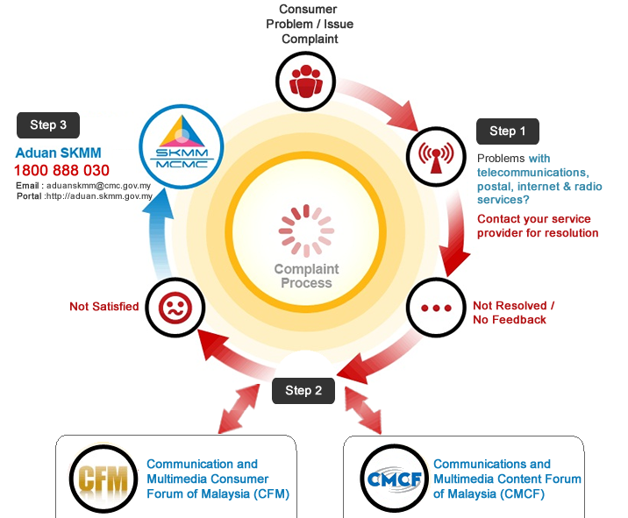
Source: Malaysian Communications and Multimedia Commission website www1.skmm.gov.my/?lang=en-US

In Saudi Arabia, the Communications and Information Technology Commission (CITC) requires service providers to establish a separate business unit to handle complaints. It also plays a direct role in the complaints handling process by reviewing providers’ complaint procedures. It also provides a dispute resolution process for when the customer and provider have been unable to resolve the dispute themselves.
Cross border redress
Although sector specific ADR schemes are commonplace in the European Union, there are a number of shortcomings that hinder their effectiveness: including gaps in coverage, lack of consumer and business awareness and uneven quality of procedures. It is important that such shortcomings are addressed where consumers are making cross-border transactions in a digital environment.
Proposed new legislation will require all member states to provide for consumers and traders to have recourse to a quality ADR scheme to resolve disputes around the sale of goods or the provision of services, including through online means. This may be provided using existing ADR schemes and adjusting their scope if necessary, or by creating new ADR entities. Each Member State will have to ensure that a competent authority is responsible for monitoring the schemes. Strict guarantees of confidentiality and data protection will apply.
The schemes will be encouraged to join networks of ADR entities in sector-specific areas and to co-operate with national authorities responsible for enforcing consumer protection legislation.

Section 4: What are the organisational methods and successful practices used by NRAs to enforce their national laws, rules and regulations governing consumer protection in a converging environment?
Effective enforcement of national policies and regulations on consumer protection is a critical component of safeguarding the public interest and helping to protect consumers. As the ITU Study Group survey found, many NRAs are experiencing difficulties in relation to enforcement within the converging environment. The main stumbling block appears to be the need for additional legislation or improved legislation. In addition many respondents were experiencing structural problems within the consumer protection agencies and a lack of expertise or personnel to administer the regulations. One quarter of respondents referred to a lack of consumer education and consumer awareness of their rights.
Structural issues and division of responsibilities
In Turkey responsibility for consumer protection is divided between the Information and Communication Technologies Authority (ICTA) (www.btk.gov.tr), which has a consumer protection section, and the Directorate General for Consumer Protection and Competition (www.tuketici.gov.tr), which is part of the Turkish Ministry of Customs and Trade. There is a clear division of responsibilities between the two bodies, with formally agreed principles about the division of work. For example if a consumer complaint about telecommunication services is sent to Directorate General for Consumer Protection and Competition, this is forwarded to ICTA if appropriate.
Although the respective regulators report this practice as working well, the Turkish Telecom Group reported a number of difficulties to the Study Group around the regulation of converged services. These included “conflict and confusion among different authorities; the impact of convergence on competition; difficulties in analysing the converged services for regulations or rules; and the prevention of negative impacts of regulation on the development and improvement of converged services”.
In China, where the State Council has set a target of 2013 for full telecom and media convergence, the two regulators concerned – the Ministry of Industry and Information Technology (MIIT) and the State Administration of Radio, Film and Television (SARFT) take different approaches to regulation. Censorship of content remains under the control of broadcasters and SARFT, which appears to have created difficulties for telecommunication providers who would like to expand their IPTV and mobile services. To date there has been a relatively low uptake of IPTV and mobile TV services in China, compared with the huge subscriber base for fixed broadband and 3G mobile subscribers.
In South Korea by contrast, the broadcast regulator and Ministry of Telecommunications reached agreement in 2006 (after lengthy debate) to have joint control over IPTV services. Since that time there has been a rapid growth in IPTV subscribers, reported by the IPTV operators to have increased to 1 687 833, a 34 000 rise in the six months to January 2013, due mainly to a rapid growth in consumers using real-time services.
Adequate resources for enforcement, consumer education and awareness
In Colombia, responsibility for consumer protection regulation for all information and communication technology services lies with the Comisión de Regulación de Comunicaciones (CRC). Consumer protection legislation has been updated specifically to take account of converged services. Resolution 3066 defines specific rules for the sale of bundled services, as well as best practice around communications with users through offices, hotlines, social networks and SMS. However, in order to successfully implement the changes, the CRC will need sufficient resources for both for enforcement, consumer education and information campaigns.
In the UK, the government has proposed legislation for a new Consumer Bill of Rights. The aim is to develop a new framework that will reduce regulatory burdens on business (by having a single consumer rights framework rather than the current 12 pieces of legislation) that is future proofed to accommodate future innovations and which can support consumer confidence by putting appropriate safeguards in place.
If enacted, the Bill will modernise 30-year-old consumer laws to create clear rights for consumers of digital content, including for downloads, content on disk, streamed content and content accessed in the Cloud. It requires that such content must match any description given and any trial version or demo as well as being of "satisfactory quality ... [meeting] a reasonable person's expectations taking account of all relevant circumstances." A trader supplying digital content must have the right to supply that content and should not put the consumer in a position where they are breaching copyright.
Regulation of service standards
In its survey response Brazil reported some difficulties in handling converged services – due to a lack of experience of coordination/cooperation amongst the relevant agencies; and because of a lack of legal procedures to address convergence.
Although the Ministry of Communications has overarching responsibility for formulating national policy on digital inclusion, radio and TV, postal services and telecommunications, the National Telecommunications Agency (Anatel) has specific responsibility for promoting the development of the Brazilian telecommunications sector. Its powers include licensing, regulation and supervision. The regulator’s decisions can only be challenged through the courts.
Consumer protection is regulated by the Consumer Defence Code (Código de Defesa do Consumidora), which is administered through a number of different agencies.
Access to the Brazilian Digital Television System (SBTVD), launched in 2007, is open and free of charge and allows the transmission of high quality content in terms of image and sound, both for fixed and mobile devices. Consumers have access to digital TV through their TV sets and mobile phones, with access to high definition services and interactivity for mobile phones, mini-televisions and laptops. Interactive services are a key feature – users can use the remote control to answer tests, find information about programming, buy advertised products, participate in surveys and carry out banking.
One of Anatel’s responsibilities is the regulation and protection of Pay TV Subscribers’ Rights, including in relation to “combo services,” which bundle together Pay TV, telephone and Internet broadband services. Under new legislation, future licence permissions to offer Pay TV will allow the use of any available technology to provide the service. This will unify the Brazilian Pay TV rules. Anatel expects Brazil’s pay-TV sector to grow to 35 million subscribers by 2018 as a result.
Whilst opening up the market to telecommunications providers the new framework also extends responsibility for satisfying stipulated quotas for local content on pay-TV programming, traditionally associated with broadcasting regulation.
Anatel has a reputation for being tough on quality of service standards. In 2012 it banned sales of mobile phone subscriptions for 11 days because of poor quality of service and growing customer complaints. It is now reported to be taking a tough approach to the regulation of Pay TV. This follows a doubling of the number of subscriber complaints between 2010 and 2011, particularly in relation to quality of service standards. Anatel has requested future investment plans and customer service targets from operators.
Getting the right balance between privacy of personal data and innovation in ICT products and services
With converged services regulators have to strike a find balance between enforcement of personal privacy measures and a regulatory framework that incentivises businesses to develop innovative ICT products and services.
In Burundi for example, an increase in mobile phone crime, with the resultant rise in anonymous threats against individuals, fraud, bank theft and misuse of stolen SIM cards, had undermined mobile phone subscribers’ trust in the security of their communications. Numerous complaints were made to the operators and the regulators. Cognisant of the importance of consumer confidence for driving market growth, the government introduced a number of measures to try and contain the problem. These include obligations on operators to install monitoring equipment and provide call records if requested by the police and/or the regulator.
Many Latin American many countries, including Argentina, Brazil, Costa Rica and Mexico have enacted rights based legislation to protect the privacy of consumers’ data, limiting its collection and use by third parties. The overarching rights based approach provides a constitutional guarantee over ‘the use of images, privacy, honour, self-determination and freedom of information.’
Under this approach, individuals have the right to access their personal data, and to opt out of its uses for advertising, marketing and market research purposes. In Brazil legislation being developed includes the right to compensation for the misuse of personal data. In Costa Rica a separate data protection authority is being created to oversee the legislation and sanction any breaches of it. In Mexico, regulations on the use of personal data include specific rules for the collection and use of data in cloud computing, including an obligation to notify users on how their data is being used and/or disclosed.
By contrast, in the United States the government has favoured a self-regulatory approach to data protection, combined with sector-specific targeted measures. For example, in March 2012 the Federal Trade Commission (FTC) published a report on consumer privacy, which included a series of non-binding, best practice principles (see Box 2).
Box 2: US Federal Trade Commission Best Practice Guidelines on privacy of consumers’ data
Privacy by Design
The protection of the privacy of consumers’ data should be incorporated in every stage of the service and product development process. This includes provision of a reasonable level of security, limiting collection to relevant data, limiting the length of time data is stored, and putting in place procedures to ensure the accuracy of the data held.
Simplified Choice for Businesses and Consumers
It should be easy for consumers to state their preferences about the type of information about them that is shared and to decide who it is shared with – for example through a “Do‐Not‐Track” facility that enables them to opt‐out of online tracking.
Greater Transparency
Companies should provide details about the type of consumer information they collect and how it is used, as well as providing consumers with access to their data.
Source: Protecting Consumer Privacy in an Era of Rapid Change: Recommendations for Businesses and Policymakers, United States Federal Trade Commission, 2012

Section 5: Guidelines and recommendations for successful methods and practices for meeting the challenges of convergence
Two-thirds of the survey respondents overall agreed there was a general need for more guidelines and recommendations related to consumer protection in a converged environment. The following guidelines and best practice recommendations bring together survey findings with examples gathered for the preparation of this report.

Golden rules for convergence
Update existing legislation/regulations to make them fit for purpose in a converged regulatory framework
• Tackle any potential technical/infrastructure barriers that may deter consumers from subscribing to new products and services (e.g. lack of access/interruption to broadband supply) These might include measures to oversee the use of traffic management techniques to deter unfair discrimination between market players; supported by minimum quality of service requirements to ensure customers have reliable access to new services, such as Cloud services.
• Ensure full use is made of relevant complaints statistics when formulating policy to tackle any gaps in the legislative or regulatory framework.
• Review the framework for content regulation; particularly how it relates to the use of non-broadcast transmission of content – a stable legal framework is essential for making the business decisions that will encourage development and growth of converged services.
• Always use impact assessments to support evidence-based policy making. Gather information from consumers about their experiences and keep abreast of patterns of consumer behaviour. Look at switching patterns across all platforms and types of product (i.e. individual and bundles). Identify what consumers actually want/need rather than what you think they need using consumer research, usage surveys and consumer complaints data as reference sources.
• Identify areas where use of data and exploitation of data overlap (e.g. between advertising regulation and privacy regulation), which is likely to fall out with ‘traditional’ communications regulation networks – and work more closely and effectively with other bodies to ensure consumers are protected and the ICT market can flourish.
• Future proof new regulatory measures to ensure they can keep pace with rapid technological change.
Consumer education and information
• Ensure that the regulatory framework promotes sufficient competition and choice for consumers; and that they are able to switch between providers seamlessly if they choose. Although there are clear benefits for consumers in purchasing bundled products in terms of price and convenience, it may make it more difficult for compare different offers and switch between them.
• Ensure consumers have access to timely and accurate information, including about speeds and data traffic management. If there is discrimination between services and/or practice such as web blocking, consumers will be made aware of it and services will be priced accordingly.
• Ensure that consumers are informed about potential security and privacy challenges they may face in e-commerce and m-commerce services and the measures available, which can be used to limit the risks
Build consumer trust in converged services
• Promote and safeguard E-commerce and mobile commerce by introducing measures to build trust amongst consumers.
• Encourage operators to develop security precautions including built in security features to prevent unauthorised transactions and data breaches.
• Ensure consumers have confidence that they are secure when using on-line services. Consumers should be able to expect a reasonable level of security for their data, with collection limited to relevant data, retention subject to certain timescales and reasonable procedures to ensure its accuracy. They should be able to understand what and how information is shared and with whom and have the choice to opt-out of online tracking practices.
• Recognise the need to protect and educate consumers with different access needs who may be particularly susceptible to deceptive commercial practices or have difficulties fully understanding payment mechanisms.
Enforcement
• Provide for a strong, well-resourced consumer protection regulatory team or separate agency with communications expertise.
• Agree a clear division of responsibilities between the different regulatory authorities concerned. This might take the form of a signed memorandum of understanding (MoU), including arrangements for sharing information and resources as appropriate.
• Distinguish between implementation failures/shortfalls/obstacles and issues around the actual legislation/regulation.
• Establish a variety of ways to identify potential or actual breaches to regulations. This could be through monitoring activities, self-reporting (for example from service providers who have detected breaches in security), establishing complaint and dispute resolution mechanisms whose scope covers all aspects of converged services, and making provision for cross-border cooperation and coordination of regulatory principles where possible.

Section 6: Summary and conclusions
Putting the consumer at the heart of the regulator’s decision making maintains the focus on competition for delivering consumer benefit and helps to address areas where the market does not fully deliver.
The majority of survey respondents have consumer protection policies in place, including playing some role in handling consumer complaints, or else a separate consumer protection agency has responsibility for telecomm consumers. However many respondent countries are facing difficulties with enforcement and/or encouragement of consumer protection measures, with lack of resource and expertise common themes. Very few respondents had updated their regulation/legislation to address issues around convergence, even though converged services are widely available. The majority still have separate regulators for telecoms and broadcasting services respectively.
So what can be done to develop and/or maintain a consumer protection framework that is fit for purpose in the converging environment? The “Golden rules for convergence” although not a panacea, provide a useful starting point.
Given the pace of change compared with the time it takes to introduce and implement new legislation and regulations it is difficult (but nevertheless important) to try and ‘future proof’ regulation. The ideal approach is to not to aim for a ‘big bang’ to the framework but to consider incremental changes that address the main threats (e.g. misuse of personal data) whilst maintaining the benefits (e.g. tailored content).
What is needed is a regulatory framework that balances the interests of suppliers and users, in areas such as the protection of intellectual property rights, and digital rights management, without disadvantaging innovative e-business models. For example, E- and M- commerce offers great opportunities for opening up cross-border trade, providing access to goods and services for previously underserved communities.
One of the key challenges for regulators is to establish a culture of security that promotes trust in ICT applications, one in which there is effective enforcement of privacy and consumer protection. Given that converged services are global, the need to strengthen cross border cooperation is ever greater.

Contribution to the Introduction of the Draft Report to Question 18-2/1, Document 1/167-E, Source: BDT Focal Point for Question 18-2/1, Third Meeting of ITU-D Study Group 1, Geneva, 10-14 September 2012.
Source: ITU Survey responses, and Study Group 1 Question 18-2/1 submissions.
Turk Telekom, U‐COM Burundi, ARCTEL‐CPLP, African ICT Consumers Network (AICN)
Those countries participating in the survey were Azerbaijan, Bahrain, Belgium, Bhutan, Bolivia, Brazil, Bulgaria, Colombia, Côte d'Ivoire, Cyprus, El Salvador, Honduras, Italy, Lithuania, Mali, Mexico, Mongolia, Oman, Portugal, Qatar, Rwanda, Senegal, South Africa, Sudan, Swaziland, Switzerland, Syria, Thailand, Tunisia, Uganda, Uruguay, Vanuatu, and Venezuela.
These are the 49 least developed countries recognized by the United Nations.
Data relates to survey respondents only
Six in developed countries, one in a transition country, eight in developing countries and four in least developed countries.
Three out of four developed countries, two out of seventeen in developing countries, and one out of five in a least developed country.
According to responses provided to the annual ITU telecommunication/ICT regulatory survey.
ITU Broadband Commission Report p.70 – The State of Broadband 2012 Achieving Digital Inclusion for all www.broadbandcommission.org/Documents/bb-annualreport2012.pdf
These include the Tanzanian Communications Regulatory Authority (2003); The Australian Communications and Market Authority (ACMA) – 2005, the Bhutan Information Commission and Media Authority (2000) the Malaysian Communications and Multimedia Commission (1998), the UK Office of Communications (Ofcom) (2003); and the Independent Communications Authority of South Africa (ICASA) (2005).
Network operators that retransmit broadcasting signals and offer them to the public, e.g. cable or satellite operators, mobile operators, IPTV providers.
ITU survey for the creation of a compendium on telecommunication/ICT consumer protection case studies in a converging environment, July 2012
A recent Eurobarometer survey found that 40% of users were concerned about their data being compromised online and 38% were worried about the security of online payments (Special Eurobarometer survey 390, ‘Cyber security.’
For example, they can communicate through a synchronous mode (telephone conversations, instant messaging or chat rooms etc) or through asynchronous mode (e-mail, blogging, text messaging, discussion boards).
Voice, data, video, and pictures
A word used to describe users that both consume and produce goods and services, attributed to Don Tapscott as defined in “Wikinomics”, Don Tapscott, Anthony D. Williams, Wikinomics: How Mass Collaboration Changes Everything, Portfolio Trade, 2006. ISBN 1-59184-367-7.
Undertaken in 2011 and approved with Resolution no. 713/11/CONS
www.misurainternet.it/
Document 1/162-E18 July 2012, op.cit.
www.physorg.com/news/2011-06-dutch-parliament-mobile-net-neutrality.html
www.broadbanduk.org/category/open-internet/
Department for Culture, Media and Sport Communications Review Seminar Series, The Consumer Perspective, http://dcmscommsreview.readandcomment.com/consumers/
Document 1/162-E 18 July 2012, Türk Telekom Group (Turkey) Proposed text for Draft Report on Question 18-2/1
Dominant telecom carriers are allowed to offer bundled services, including services subject to price regulation, unless those offerings may harm competition and/or consumers.
Document 1/162-E18 July 2012, op.cit.
www.fcc.gov/document/chairman-genachowski-announces-post-superstorm-sandy-field-hearings
www.garanteprivacy.it
Personal Data Protection Code (Decree No. 196 dated 30 June 2003): Italy’s consolidated statute transposing EC directives 95/46 (protection of personal data), 2002/58 (electronic privacy) and 2006/24 (traffic data retention) regulating application of data protection principles to various sectors, setting up the Italian data protection authority and laying down the DPA’s powers and enforcement mechanisms.
Resolution No. 113/2009 issuing Regulations on Protection of the Confidentiality and Privacy of Beneficiary Data
www.tra.gov.om/newsite1/NewsDetails.aspx?newsid=273
See for example the Guardian report “Google's privacy policy: EU data protection chiefs 'to act within days'” Monday, 8 October 2012.
Communication from the Commission to the European Parliament, the Council, the European Economic and Social Committee and the Committee of the Regions, Unleashing the Potential of Cloud Computing in Europe, COM (2012) 529 final, Brussels, 27.9.2012
European Parliament Directorate-General for Internal Policies, Policy Department C, study on Fighting cyber crime and protecting privacy in the cloud, PE 462.509
European Network and Information Security Agency (ENISA), Cloud computing: benefits, risks and recommendations for information security, Heraklion, November 2009
In Japan, the sales of NFC-mobile handsets reached more than 64 million as of the end of 2009 (FeliCa, 2010).
2007 Electronic Financial Transactions Act (EFTA) and the E-commerce Consumer Protection Act (ECPA)
OECD Report on Consumer Protection in Online and Mobile Payments, 17 August 2012 DSTI/CP(2010) 22/FINAL
Proposal for a Directive of the European Parliament and of the Council on alternative dispute resolution for consumer disputes COM (2011)793 final, Brussels,29.11.2011 and Proposal for a Regulation of the European Parliament and of the Council on online dispute resolution for consumer disputes COM(2011)794 final, Brussels, 29.11.2011
http://advanced-television.com/2009/07/06/iptv-subs-increases-in-korea/
National Law 1480, updated in 2011, included changes relating to protection of consumer health and security, protection of minors, access to information and aspects such as guarantees for goods and services. User regulation CRC 3066, also updated in 2011, made changes relating to the use of technologies for communication with companies, maximum response times, access to information, and rules for packet services.
op.cit.
www.gov.uk/government/news/new-proposals-for-consumer-rights
Anatel is a special agency created by the General Telecommunications Law (LGT). It is administratively independent and financially autonomous with no hierarchical subordination to any government agency.
Law 8,078, of September 11, 1990
Regulation of Pay TV Subscriber’s Rights Protection and Defense – Anatel Resolution nº 488/2007 modified by Anatel Resolution nº 528/2009; new Law 12.485/2011.
Anatel data shows the number of pay-TV subscribers in Brazil reached 15.1 million in August 2012, up 30 percent from the same month a year earlier. An index measuring penetration per household rose to 25.5 percent in August, up from 19.4 percent on the previous year America Movil has a market share of 37.2 percent, followed closely by DirecTV, through its Sky Brasil brand, with a 31.2 percent share.
Which are overseen by the Brazilian National Cinema Agency.
According to a report by Chris Forrester on advanced television.com http://advanced-television.com/2012/09/19/brazil-wants-better-customer-service-from-pay-tv/
Document RGQ18-2/1/16-E, 4 January 2012, Burundi, Combating mobile telephone crime in Burundi: directives for operators and obligations of the regulator.
Personal Data Protection Act (2000).
Regulations of the Federal Law for the Protection of Personal Data Held by Private Parties (2011).
Protecting Consumer Privacy in an Era of Rapid Change: Recommendations for Businesses and Policymakers, FTC 2012.
As referred to in the study prepared for the ITU Connect Americas Summit 2012, Regulatory Impact of Convergence and Broadband for the Americas, prepared by ITU expert, Janet Hernandez.
One of the UN Broadband Commission for Digital Development’s target for 2015 is that entry level broadband services should be made affordable in developing countries – amounting to less than 5 per cent of monthly GNI per capita –in order to ensure that their populations can engage fully in the knowledge society.
The application of the European Union’s Audiovisual Media Services Directive 2010/13/EU (‘AVMSD’) is reported to have allowed the media services market to grow from a small number of service providers to more than 7 500 broadcasters; and growth in video on demand services.
Note the EU proposal to repeal the existing E-Signatures Directive and replace it with broad framework to enable mutual recognition and acceptance of electronic identification. Authentication, signatures and related ancillary trust services (Council document 10977/12).
OECD Report on Consumer Protection in Online and Mobile Payments, 17 August 2012 DSTI/CP (2010)22/FINAL.

